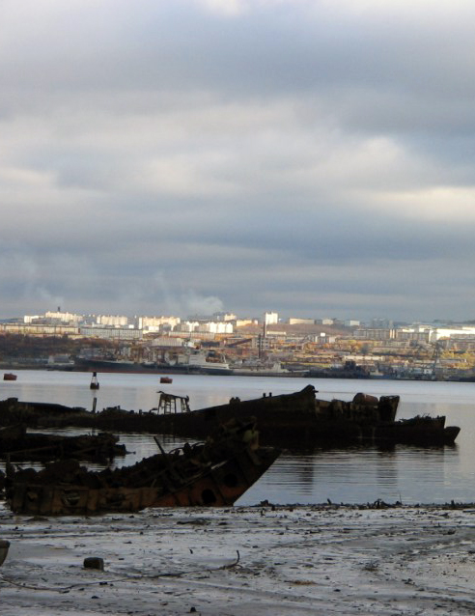
GLOBAL ENVIRONMENTAL FACILITY

UNITED NATIONS ENVIRONMENT PROGRAMME

RUSSIAN FEDERATION – SUPPORT TO THE NATIONAL PROGRAMME OF ACTION FOR THE PROTECTION OF ARCTIC MARINE ENVIRONMENT
(NPA-ARCTIC PROJECT)

DEMONSTRATION AND PILOT PROJECTS

Outputs and outcomes, their assessments
and scaling up in the Arctic context

Moscow 2011

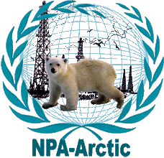
GLOBAL ENVIRONMENTAL FACILITY

UNITED NATIONS ENVIRONMENT PROGRAMME

RUSSIAN FEDERATION – SUPPORT TO THE NATIONAL PROGRAMME OF ACTION PLAN FOR THE PROTECTION OF ARCTIC MARINE ENVIRONMENT
(NPA-ARCTIC PROJECT)

DEMONSTRATION AND PILOT PROJECTS

Outputs and outcomes, their assessments
and scaling up in the Arctic context

Prepared by S.B. Tambiev

Edited by B.P. Melnikov

Scientific World

Moscow 2011

Prepared by S.B. Tambiev

Edited be B.P. Melnikov

Demonstration and Pilot Projects. Outputs and outcomes, their assessments and scaling up in the Arctic context/ Prepared by S.B. Tambiev; edited be B.P. Melnikov.: – M.:
Scientific World, 2011

This publication offers a brief description of the outcomes and outputs of the demonstration and pilot projects implemented in a framework of the UNEP/GEF Project “Russian Federation – Support to the National Action Plan for the Protection of Arctic Marine Environment” (The NPA-Arctic). The full version of the reports concerning all the demonstration and pilot projects are published on the NPA-Arctic Project Site (http://npa-arctic.ru/html/demos.html) and are publicly accessible.

© NPA-Arctic Project, 2011

© Scientific World, 2011

Table of Contents

1. Introduction 4
2. Completed Demonstration and Pilot Projects 5
2.1. The Environmental Co-Management of Extracting Companies, Authorities and Small-In-Numbers Indigenous Peoples of the North Demonstration Project 5
2.2. Environmental Remediation of Decommissioned Military Bases on Franz Josef Land Demonstration Project 8
2.3. The Cleanup of the Arctic Marine Environment with Brown Algae Pilot Project 12
2.4. The Pilot Project “Cleaning Bottom Sediments of Kola Bay from Hazardous Substances. Phase 1. Monitoring Hazardous Substances in Kola Bay Bottom Sediments.” 16
2.5. Developing Bioremediation Technology for the Cleanup the Oil-Contaminated Onshore Areas in the Arctic 21
2.6. Cleanup of the Bay of Tiksi Seafloor from Sunken Logs and Shipwrecks Pilot Project 24
2.7. Pilot Project: Environmental Remediation of the Former Military Site near Pokrovskoye Settlement, Onezhsky Rayon, Archangelsk Oblast of the Russian Federation 28
2.8. Pilot Project: Development of technology for cleaning up the Arctic decommissioned sites of the Russian Ministry of Defense from hazardous waste as demonstrated on Alexandra Island of Franz Josef Land Archipelago 31
2.9. Pilot project: Cleanup of tiksi bay seafloor from sunken logs and wrecks. Phase 2 36
2.10. Pilot Project: Localisation and removal from a thermokarst crater of two radioisotope thermoelectric generators (RITEGs) of GONG type at the Kondratiev navigation beacon site in Ust’-Yanski Ulus of Republic of Sakha (Yakutia 40
2.11. Pilot Project: Inventory of Pollution Sources at the Decommissioned Military Sites on the New Siberian Islands 44
2.12. Pilot Project: Elaboration of the Process and Logistics Options for the Implementation of the System for Collection and Utilization of PCB Wastes and PCB-Containing Equipment in the Russian Arctic 52
2.13. Pilot Project: Developing Healthcare Improvement Recommendations for Indigenous People Exposed to Intensive Adverse Impacts from Contaminated Environment in the Russian Arctic 55
2.14. Pilot Project: Establishing the System of Obsolete and Banned Pesticides Destruction in the Russian Federation through Innovation Technologies 59
2.15. Pilot Project: “Improving the Oil Spill Response System in the Arctic Context for the Protection of Coastal Areas that are Specifically Responsive to Oil Products (as Demonstrated in the Context of the Barents and White Seas)” 61

1. Introduction

The Project Document of the UNEP/GEF Project “Russian Federation – Support to the National Action Plan for the Protection of Arctic Marine Environment” (The NPA-Arctic) included the component for the preparation and implementation of three demonstration projects that were to serve as a broader basis for the application of approaches and methods aimed at preventing environmental violations and at restoring environment in Russia and in the Arctic and non-Arctic states. The goal of one of them was to facilitate joint environmental management by the authorities, extracting companies and small-in-numbers indigenous peoples of the North. Project 2 concerned itself with environmental reclamation of the areas within the abandoned military facilities in order to convert them for civilian use. Project 3 was supposed to demonstrate the brown algae capacity of cleaning-up contaminated marine waters.
The Project Document also proposed to consider whether it would be possible to prepare additional demonstration projects.
As specified in the Project Document, all three demonstration projects were prepared and successfully completed as part of the NPA-Arctic Project. Also, 12 more pilot projects were prepared and completed supported by the Project Steering Committee.
The proposals for the additional pilot projects were prepared in close cooperation with the local administrations, in whose territory the proposed projects were to be implemented. The geography of the selected projects covered the western, central and eastern part of the Russian Arctic. In some cases, local administrations co-financed pilot projects (Archangelsk Oblast). The co-financing partners included US EPA (the Franz-Josef Land Project and the Pesticide Project), the Island Ministry of Environment (the Tiksi Bay Project), and the Nordic Environment Finance Corporation (the Emergency Oil Spills Response Project).
All the proposals for the additional pilot projects were reviewed at the Steering Committee meetings. Out of the proposed list, the Steering Committee selected the most relevant and prepared projects and approved them for implementation. The selection process was based (i) on the importance of a given project for the enhancement of the environment in a given region, (ii) on whether it could be replicated in other Arctic regions, and (iii) on its geography. Following the selection process, the NPA-Arctic Project Management Team prepared the project documentation for the approved projects and selected contractors for each project through competitive bidding.
This publication offers a brief description of the outcomes and outputs of the demonstration and pilot projects outlining the project implementation timeframe, contractors and recommendations for further steps to develop the results.
The full version of the English and Russian language reports concerning all the demonstration and pilot projects are published on the NPA-Arctic Project Site (http://npa-arctic.ru) and are publicly accessible.

2. Completed Demonstration and Pilot Projects

2.1. The Environmental Co-Management of Extracting Companies, Authorities and Small-In-Numbers Indigenous Peoples of the North Demonstration Project

The Project Goals
(a) Facilitating joint management of environment protection by executive authorities, local administrations, extracting companies and the indigenous peoples of the North in traditional indigenous communities and economic activity of these peoples;
(b) Developing administrative, economic, financial and social mechanisms of environmental co-management by establishing, for example, coordination councils or other bodies, serving as a forum to identify and solve potential conflicts between the indigenous population, industrial companies, executive authorities and local administrations and other stakeholders.
The Project was implemented by the Batani International Development Fund for Indigenous Peoples of the North, Siberia and the Far East with the participation of the Russian Association of small-in-numbers indigenous peoples of the North, Siberia, and the Far East (RAIPON) and a foreign partner, UNEP/GRID-Arendal, covering three model regions such as Yamalo-Nenetsky Okrug, Nenets AO, and the Republic Sakha (Yakutia).
The Project Implementation Period 15 November 2007 - 15 February 2009
The Project Activities
To attain the Project goals, the Project implemented the following activities in the three model regions:
Phase 1: (initial)
On January 25, 2008, Moscow hosted an inception workshop (coordination meeting) aimed at reaching a consensus concerning objectives and expected results among the Project executive team, the UNEP/GEF Project Implementation Unit, and all stakeholders of the main content of the Project and expected results. This initial activity was necessary for the successful implementation of the entire Project.
Phase 2:
Analyses of the environmental co-management practice was conducted, and improvement recommendations were developed for three model regions (i.e. seminars, review of the results, problems identification and prioritization), including the efficiency analyses of the organizational framework and functioning principles of the traditional nature use territories and other existing mechanisms and principles of the interrelation between indigenous organizations, authorities, local self-governments and industrial companies in seeking solutions to nature use issues in both Russia and abroad. Reasons were established for the current and potential conflicts in environment protection and nature resources use. Recommendations were developed to address these problems.
Phase 3:
Regional consultations were held in an attempt to accommodate interests and to coordinate the activities of the stakeholders participating in environmental co-management. This phase developed the main principles and methods of cooperation in addressing issues related to co-management, in adopting a common approach by all participants in this process. First steps were taken to establish institutional mechanisms of interrelations between the indigenous peoples, authorities and private businesses. A model ethno-ecological council was established as a result of the Project’s third phase. Ethno-ecological councils will serve as a forum to identify and solve potential conflicts between the indigenous people, industrial corporations, executive authorities, local self-governments and other stakeholders.
Phase 4:
Round tables were held to review the Project outcomes and outputs. As a follow up of the Round Table recommendations, a joint action plan was prepared for the executive authorities, local self-governments, extracting companies and the indigenous communities. The plan will guide environmental co-management and preservation of the traditional way of life and habitat of the small-numbered indigenous peoples by balancing the interests of the indigenous people, extracting companies, and authorities in addressing the economic and environmental concerns of the North. On 5 December 2008, the State Duma of the Russian Federation hosted the Project completion round table, with the participants, including representatives of federal executive authorities and other stakeholders, to discuss and disseminate the positive experience in co-management in both the model territories and other parties of the Russian Arctic.
The Project Outcomes
During the Project implementation, the Project experts reviewed the applicable federal and regional legislative framework concerning possible development of environmental co-management. It was found that the existing legislative framework had prerequisites for the development of environmental co-management but these were still underdeveloped with respect to establishing the corresponding institutions and methodologies to realize this potential.
The Project experts and regional project coordinators collected materials characterizing the existing practice of interaction between the authorities, industrial corporations, nongovernmental organizations and business entities of small-in-numbers indigenous peoples of the North in the area of environmental co-management in three model regions including the operation of the territories of traditional nature use of regional importance in the Nenets AO. It was found that in the three model regions, the environmental co-management regional legislation is well ahead of the federal level legislation, while the existing practice of agreements and contracts between the authorities, extracting companies and indigenous people organizations allows – though indirectly – recognizing the interests of the indigenous peoples. But regional initiatives are inhibited by lack of the corresponding provisions in the federal legislation, mechanisms and methodologies approved at the federal level. Some regional initiatives and the federal laws themselves are subject to gradual recession. Also, the existing socioeconomic agreements and contracts do not pay much attention to an environmental component. The Project experts developed improvement recommendations for the federal and regional legislation, as well as methodologies and draft regional regulations as new effective legal and economic mechanisms to balance the interests of the extracting companies and indigenous peoples in managing economic and environmental problems while preserving traditional lifestyles and territories of the indigenous peoples.
The Demonstration Project tested a methodology for training indigenous peoples in the use of traditional knowledge to map territories of traditional nature use. The database of information collected under this methodology will facilitate ethno-ecological monitoring. The Project also tested guidelines to assess the quality of lands, which are native territories of the indigenous people of the North, Siberia, and Far East of the Russian Federation, as well as to map the boundaries of the territories of traditional nature use. Guidelines were also offered to determine the amount of damage to the users of lands and other natural resources in the indigenous people communities and in the areas of traditional lifestyle of the small-in-numbers indigenous peoples of the North, Siberia, and the Far East of the Russian Federation.

A Guide was prepared to help establish a territory of traditional nature use (TTNU). For the territories of traditional nature use co-management model, the Project proposed a TTNU Coordination Council, which is a coordination body to ensure integrity of management and control across the territories of traditional nature use with due regard to the traditions and customs of indigenous peoples.
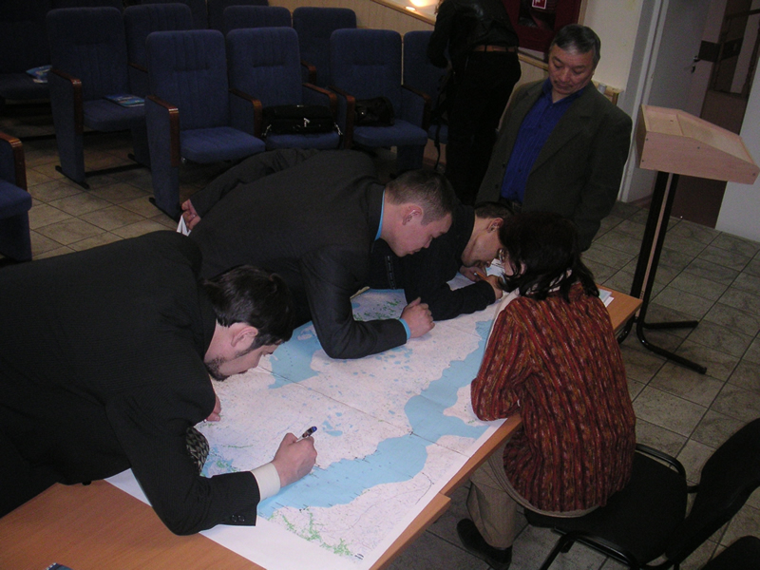
Figure 1. Training Indigenous Peoples in the Use of Traditional Knowledge for Mapping Territories of Traditional Nature use

For a model of a forum or platform to coordinate local self-governments, executive and legislative authorities at the regional level, designated state environmental authorities, and nongovernmental organizations of the small-in-numbers indigenous peoples of the North, the Project proposed an ethno-ecological council as an environmental co-management model in the indigenous communities and territories of traditional nature use. The ethno-ecological councils were established in two model regions, i.e. in Yamal-Nenets Autonomous Okrug (YANAO) and Republic of Sakha (Yakutia).

The ideas, methods and practical experience of the Demonstration Project were used to develop the proposed federal law “Protection of Original Habitat, Traditional Way of Life and Traditional Nature Use of the Russian Federation’s Small-Numbered Indigenous Peoples”.
As proposed by the Demonstration Project experts, the proposed law included the following provisions: (i) identifying the indigenous people communities and territories of traditional economic activities of indigenous peoples; (ii) establishing and zoning the indigenous people communities and territories of traditional economic activities of indigenous peoples; (iii) ethnological expert review of the projects to be implemented in the territories of traditional nature use; (iv) developing co-management with the participation of indigenous peoples in the indigenous people communities and territories of traditional economic activities of indigenous peoples, as well as in the territories of traditional nature use, and other provisions. The same ideas were laid down as a basis for legislative initiatives proposed for the improvement of the regional legislation in the three model regions of the Demonstration Project. These ideas were discussed by all the stakeholders in the regional workshops and round tables.

The Round Tables recommended disseminating the experience of the Demonstration Project in the other districts of these constituent subjects of the Russian Federation.

Also, in the course of the Project implementation, its preliminary outcomes were presented at international (Geneva, Khabarovsk) and regional (Murmansk, Syktyvkar, Petropavlovsk-Kamchatsky, Yuzhno-Sakhalinks) workshops and meetings attracting the interest of the authorities, corporations, and nongovernmental organizations of small-in-numbers indigenous peoples of the North. The Demonstration Project experts received proposals to prepare projects for implementation of some ideas in Murmansk Oblast, the Komi Republic, and Sakhalin Oblast.

All the analytical materials and guidelines developed under the Demonstration Project are published and could be used in other regions of the Russian Federation.

2.2. Environmental Remediation of Decommissioned Military Bases on Franz Josef Land Demonstration Project

The Project Goals

- Assessing pollution with oil products, PAHs, POPs and heavy metals, taking inventory of the pollution sources, determining their quantities, state, and threats of destruction, assessing environmental threats on the Demonstration Project sites selected within the abandoned airbase on Alexandra Island of the Franz-Josef Land Archipelago;

- Demonstration disposal of drums with waste oils, residual fuel and lubricants including activities such as draining of liquids, removal of residues, pressing of the drums, their subsequent removal from the Archipelago, and utilization at enterprises of Archangelsk Oblast;

- Assessing methods and potential for the mathballing of the PCB-containing equipment that is part of the airbase and air defense facilities on the selected site;

- Cleaning up the vacated drum storage area by using modern techniques of cleaning up ground oil contamination in the Arctic context;

- Developing remediation guidelines for the polluted territories of the abandoned military facilities in the Russian Arctic;

- Taking sample for contamination before and after remediation activities in order to determine effectiveness of the cleanup technologies applied;

- Determining legal and institutional procedures for taking the remediated territories from the jurisdiction of the Ministry of Defense and for transferring them under the jurisdiction of the Archangelsk Oblast;

The Project was implemented by the non-profit organization "Polar Research Foundation (NO "Polar Foundation”), which was in charge of the overall organization and coordination of the studies. The subcontractors included: the State Organization "State Oceanographic Institute (GU "GOIN”), Moscow; OOO I.K.M. Engineering, St. Petersburg; the North-West branch of "NPO Typhoon", St. Petersburg, the North Territorial Office for Hydrometeorology and Environmental Monitoring (Northern UGMS), Archangelsk

The Project Duration

The field works were carried out between 18 to 20 September 2007 during the run of the Michael Somov research and expedition vessel of the Northern UGMS bringing supplies to the polar stations and carrying out research under the 2007/2008 International Polar Year Program. Additional samples were taken in 2008 during the pre-project site investigations related to the development of the detailed project of the clean up of the Alexandra’s Land area. The Project was completed in October 2009.

The Project Activities

Under the Demonstration Project, the activities related to the collection and utilization of empty drums, drums with the residual fuel and lubricants, and to the cleanup of the ground from oil contamination by using degradation biological products were carried out within the abandoned Nagurskaya Military Base located on Alexandra’s Island. Three cleanup sites were selected for the Demonstration Project, but since it was not possible to work on Cleanup Site 1 (the fuel drums were on the books of the existing frontier station), the cleanup activities were only carried out on Cleanup Sites 2 and 3.
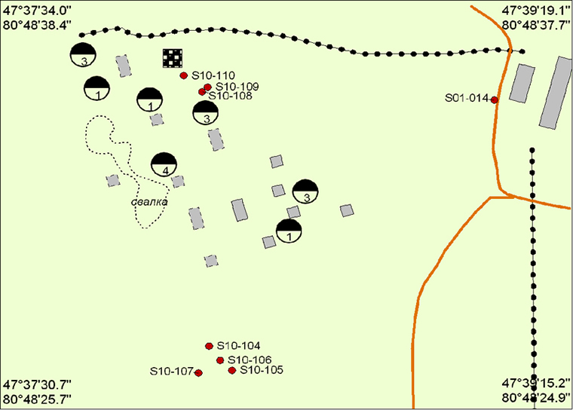
Figure 2. Schematic Map of Geoenvironmental Sampling Points on Site 10 (Fuel and Lubricants Storage near Nagurskaya) on Alexandra Island (1:5000)

Cleanup Sites 2 and 3 were located on Site 10.

The work scope was as follows:

- Removing metal scrap from the cleanup sites;
- Collecting empty drums and drums with residual fuel and lubricants from one or more areas (totaling not more than 1 ha);
- Draining the residual fuel and lubricants into tanks that are available within the facility;
- Cleansing the drums with a specialized device that provides for the regeneration of the detergent;
- Compacting empty drums;
- Packing the pressed drums and taking them to the Michael Somov Vessel, and transferring them at a later stage to metal scrap utilization organizations;
- Working the cleaned up areas with a cultivator;
- Applying two brands of organic pollutants degrading biological products on the cleaned up areas;

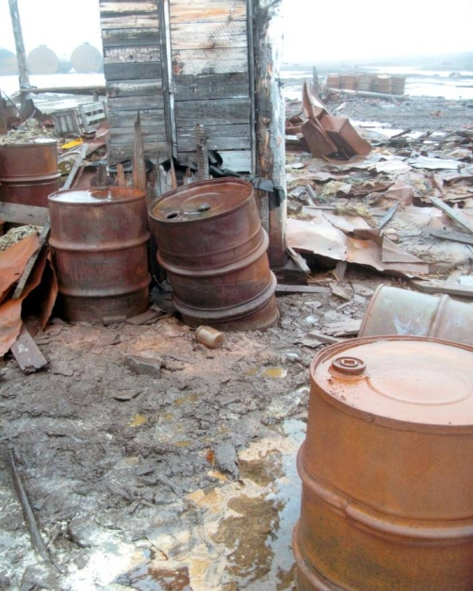
Figure 3. Abandoned Fuel Drums on Former Military Base «Nagurskaya»

Following the selection of the test cleaning areas, work was carried out (i) to remove - from the cleanup areas - and test compact fuel and lubricants drums by using a 12 t specialized hydraulic press; (ii) to take control soil samples from the areas to be remediated with biological products; and (iii) to apply two different biological products (“Devoroil”, and “Petro-Treat”) together with the required biogenic substances. Some sections treated with the biological products were covered with specialized film to provide for better temperature regime for biological products. After the completion of the works, a few compacted and good fuel and lubricant drums were brought to Archangelsk on the Michael Somov Vessel and stored on the Roshydromet Northern Department depot. The good drums were then used to test drum compacting equipment. The compacted drums were transferred as scrap to the OOO Archangelsk Metal Group depot.

The Project Outcomes

The drum disposal activities brought about the following findings:

Compacting most of the Archipelago drums needs powerful pressing or compacting equipment since the drum walls could be as thick as 2 mm. The best option is a press with a capacity of not less than 24 t.
The cleansing of drums and treatment of recycle water should be carried out in premises with positive temperatures since drums have inside a mix of residual fuel and lubricants and frozen water.
A more effective approach to cleansing the drums might be to burn out the residual fuel and lubricants by using specialized equipment that provides a sufficiently high temperature of combustion and low level of pollutants in the resulting emissions. This technique will require ongoing pollutant level monitoring of combustion gases.

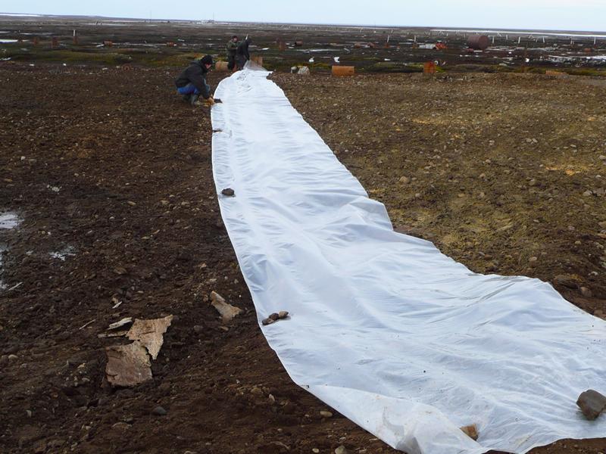
Figure 4. Bioremediation of Oily Soil

The main findings of the soil bioremediation activities are as follows:

- For soil remediation purposes, biological products should be applied in the areas with high levels of local oil contamination provided it would be possible to ensure effective performance of such biological products. Such areas should be surrounded with natural berms or artificial bunding so as to prevent washing-off of the biological products and the respective biogenic substances.

- Where possible biological products should be applied early in the warm season to ensure the best possible time for their performance.

- In order to improve the performance of biological products, various covers should be used such as specialized film or stationary polycarbonate greenhouses to ensure the best warming of the soil.

- It is possible to organize specialized remediation sites – apparently smaller in size – for biological remediation (with due regard to the above activities) of contaminated soils collected in other areas and delivered to such a remediation site.

- It is desirable to use specialized biological products that are best adapted to their application in the Arctic context. The biological basis of such products must be composed of microorganisms grown from the bacteria varieties that are natural biological degraders of hydrocarbons in the Arctic soils.

The 2007/2008 Demonstration Project, whose major goal was to investigate and cleanup the territory of the abandoned facility of the Ministry of Defense on Alexandra’s Island, generated a lot of unique information. It also tested elements of the technology that could be used in the planning and carrying out of further activities related to the cleanup of this and other similar facilities. The organizational, resource and technological provision of the forthcoming cleanup activities on the archipelago requires close cooperation with the Russian Ministry of Defense, Frontier Service of the Federal Security Service of the Russian Federation, Ministry of Economic Development of the Russian Federation, Roshydromet, the Ministry of Natural Resources and Ecology of the Russian Federation, other agencies concerned, as well as tapping of the international experience and expertise to ensure the required technological level of activities related to the utilization of hazardous waste and remediation of polluted lands.

Based on the completed activities and experience gained, guidelines were development for the remediation of contaminated areas of abandoned military facilities in the Russian Arctic. The guidelines are in line with the applicable regulatory and legal framework and take into account the current state of such facilities.

2.3. The Cleanup of the Arctic Marine Environment with Brown Algae Pilot Project

The Project Goal

- To demonstrate an economically effective methodology of using brown algae to cleanup Arctic marine areas;
- This could in future be used for a large-scale cleanup of oil pollution of the Arctic marine waters, thus reducing the impact of economic activities in Russia on international waters.

The Project was implemented by the "SIRENA" limited liability company (OOO "SIRENA", St. Petersburg). At different stages of its implementation, the Project saw the following participants: (i) Murmansk Marine Biological Institute, KNC RAS; (ii) The Main Branch of Zvezdochka FGUP – SRZ “Nerpa”(Snezhnogorsk); (iii) Lomonosov Moscow State University; (iv) Saint-Petersburg Chemical-Pharmaceutical Academy; (v) OOO “BIOTEHNKOM” (St. Petersburg); (vi) OOO "NORD-SERVICE" (Murmansk); (vii) OOO Murmansnab" (Murmansk); and (viii) OOO “BIOFRIZ” (Snezhnogorsk).

The Project Implementation Period November 2007 - December 2009.

The Project Activities

- Selecting a site for the implementation of the pilot project in the Arctic waters of the Kola Bay in the Barents Sea and carrying out preparatory works for setting up the plantation;
- Conducting a detailed survey along with hydrological and hydrochemical studies;
- Setting up the brown algae plantation on the selected site;
- Conducting ameliorative activities and monitoring of the environment and the plantation;
- Harvesting brown algae and preparing it for utilization and processing;
- Designing the scheme for the disposal of contaminated algae and processing of clean algae with the purpose of making commercial raw materials;
- Preparing the summary and assessing the results;
- Preparing a model project for the purpose of using brown algae to cleanup polluted sea waters;

The Project Outcomes

The pilot project “Cleanup of Arctic Marine Environment Using Biological Filtration Potential of Brown Algae” demonstrates an innovative method of cleanup of marine environment from oil pollution. This method is based on biological filtration capacity of a symbiotic association of brown algae and hydrocarbon oxidizing bacteria.
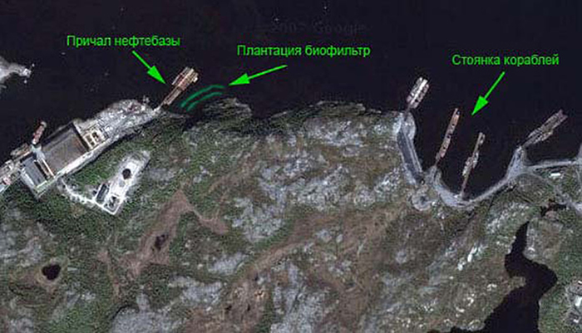
Figure 5. Satellite View of Biofilter Plantation Located Between Fuel Depot and Moorage
The new technology has been implemented at the experimental plantation of algae in Olenia Bay of the Barrens Sea. Two main sources of oil pollution in this basin are Nerpa Ship Cutting Yard, and naval ships anchored in the open-sea part of the bay.
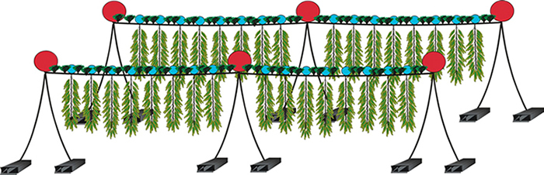
Figure 6. The Bay Floor Layout of the Biofilter Plantation
The experimental plantation was made of engineering structures with horizontal cable ropes stretched on the water surface, which provided the substrate for Fucus vesiculosus. These ropes supported 5-meter-long vertical slings, which served as substrate for Laminaria saccharina thalluses and epiphyte hydrocarbon oxidizing bacteria, at a depth of 0.5-5 meters. The floating structure had an area of 0.5 ha and was attached to artificial anchors at a depth of 15-25 meters.
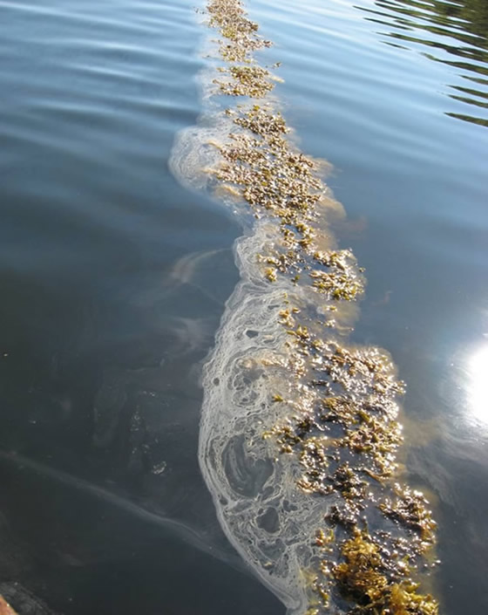
Figure 7. Pilot Sanitation Algae Plantation Prevents Oil Products from Spreading Over Sea Surface
Several major anthropogenic oil spills occurred in Olenja Bay during the project implementation period. Fucus algae at the experimental plantation directly contacted with oil film for a long time, serving as slick bars and cleaning the water surface.
Simultaneously with the tests performed in-situ at the plantation, several experiments were conducted in high seas and in the laboratory of the biological station of the Murmansk Institute of Marine Biology, located in Dalnie Zelentsy village on the coast of Barents Sea. These experiments demonstrated the potential of fucus algae to clean seawater from oil pollution.
The Project results can be summarized as the following conclusions:
- The proposed plantation design and biological filtering method can be implemented all the year round.
- The sanitary algae plantation (provided the plantation setting up technology is complied with) prevents spreading of oil products over the water surface and adsorbs oil products. It also reduces concentration of pollutants in the environment by including them into metabolism and then neutralizing them.
- The activity of hydrocarbon oxidizing bacteria (epiphytes of brown algae) grows in the presence of oil products, which is an important factor to consider during the plantation inception stage.
- A unique original finding of this project is identification of five species of dominant epiphyte bacteria, which neutralized oil products on the surface of algae.
- Individual modules of the sanitary algae plantation can be effectively used for containment of oil films and sustainable development of aquaculture in the Barents Sea.
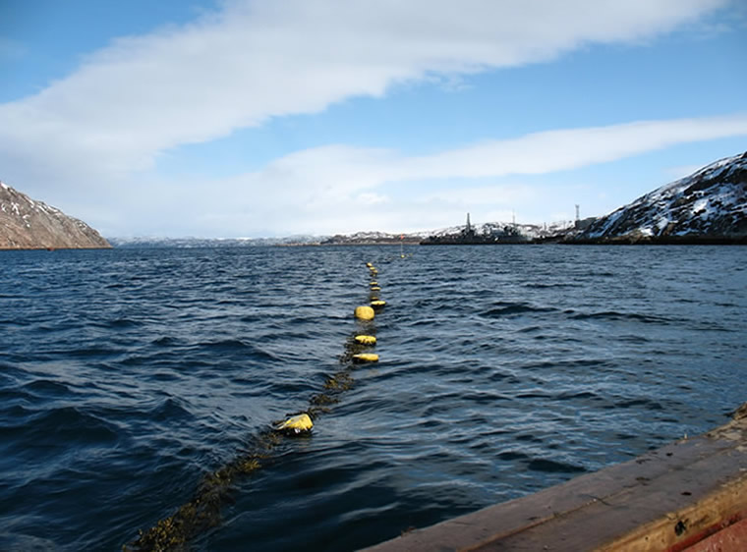
Figure 8. Horizontal Substrate Ropes for Fucus vesiculosus on Water Surface of Olenia Guba
- Both the in-situ measurements and laboratory experiments showed that one hectare of a biofiltering plantation may neutralize about 100 kg of oil products per week.
- Valuable bioactive substances can be extracted from laminaria harvested at the sanitary algae plantation.
- The prototype plantation, implemented in the Barents Sea, can be also implemented in other seas provided that certain modifications are made to take in account specific regional abiotic and biotic factors.
Built and operated in accordance with the above principle, the pilot sanitary algae station worked over 18 months under rather severe conditions. It faced several storms and confirmed the effects of localization of neutralization of hydrocarbon pollutions. The carrying structure could have a longer service life as compared to the above service life of the station.

Introduction of sanitary algae plantations is of particular importance as a tool to protect fish and crab plantations that are being established in the Murman coastal waters. The proposed brown algae-based technology of protecting marine environment from pollution could surely be used in other seas with due regard to specific features of the regions.

The pilot project implementation showed that the configuration of a bio-filter plantation for cleaning up marine areas from oil pollution depends on the geographical, hydrodynamic and hydrobiological features of the host area. The pilot project proposed a systemic model approach to the establishment of bio-filter plantations in different regions.

The results of this pilot project provided sufficient material to file a patent application “A Method of Purification of Coastal Seawater from Oil Films and Oil Products, Dispersed in the Surface Layer” (2007106573/13). The patent application was approved.

2.4. The Pilot Project “Cleaning Bottom Sediments of Kola Bay from Hazardous Substances. Phase 1. Monitoring Hazardous Substances in Kola Bay Bottom Sediments.”

The Project Goal was to monitor Kola Bay muddy grounds to identify the extent of their contamination from man-induced impacts, with the monitoring findings to serve as information framework for the development of a technical project for pollution abatement of Kola Bay and cleaning it up from highly contaminated bottom sediments.

The Project was implemented by the non-for-profit organization “Harmonious Development Ecological Foundation (EFGR)”.

The Project duration 15 November 2007 - 15 March 2008

The Project Activities

The following activities were implemented to meet the Project goal:

- Environmental monitoring was carried out. Acoustic equipment was used to conduct reconnaissance study of spatial distribution of bottom sediments in the southern part of Kola Bay. Seismic acoustic equipment was used to determine muddy bottom sediments distribution. Arial survey grounds were selected. Acoustical equipment was used to carry out arial survey. Distribution and thickness of muddy grounds were determined. Bottom samplers and samplers took bottom sediment samples at the corners and in the center of the selected arial survey grounds. The bottom sediment core samples were analyzed and the ground composition was determined.

- Analytical studies and their interpretations were done. A laboratory analyzed the bottom sediment samples for contamination with heavy metals, petroleum hydrocarbons (n-paraffins, PAH), chlorine organic pesticides and PCBs, with the follow up interpretation of the laboratory essays.

- A concluding Project meeting was held with representatives of federal executive authorities, regional authorities, and other stakeholders to discuss the outcomes of this Pilot Project and to prepare a technical project for pollution abatement of Kola Bay and cleaning it up from highly contaminated bottom sediments.

The Project Outcomes

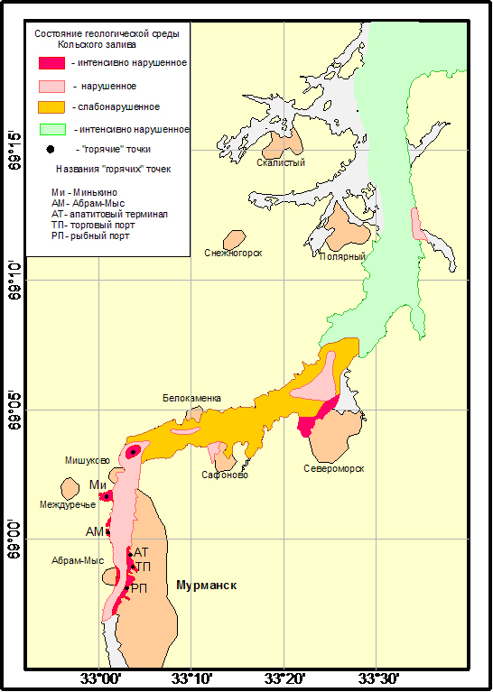
Figure 9. Geoenvironmental Map of Kola Bay was Made on the Basis of Monitoring

- Because of the combined load of man-induced impacts on the marine environment, Kola Bay faces the highest loads in the Russian Arctic. At the same time, it is till a Category I fisheries water body.

- The main sources of pollution of Kola Bat, in particular of its southern and middle parts, include industrial enterprises, municipal wastewater discharges, and operations of the civil and military fleets. Untreated discharges account for 78% of wastewater. There is an urgent need to put into operation wastewater treatment facilities in Murmansk.

- Conducted in recent years, the GU MURMS monitoring showed that the quality of the Bay waters was characterized as “moderately polluted” – “polluted” in its southern part, as “moderately polluted” in its central part, and as “moderately polluted” in its northern part.

- In some parts of the Bay, marine water demonstrates consistently high concentrations of biogenic elements, suspended solids and organic substances (for instance, at the water station near the Commercial Port).

- Oil pollution of water (oily films, dissolved oil products) is constantly observed in the Bay waters. Vessels and ships keep on discharging bilge and oily water without permits. There has been no cleaning up of the bay from oil pollution in recent years. Visible during the low tide, the wide oily strip on the steep shores is a pronounced indicator of the overall pollution of the bay surface. There is an urgent need to renew regular collection of oily patches from the bay surface and to implement measures for the prevention of unauthorized discharges of oil products into the bay waters.

- Bottom sediments accumulate oil products. The threat of continued increase in the oil pollution of water and bottom sediments in Kola Bay is associated with the forecasted increase in the scope and scale of oil products carriage and overhaul through Kola Bay.
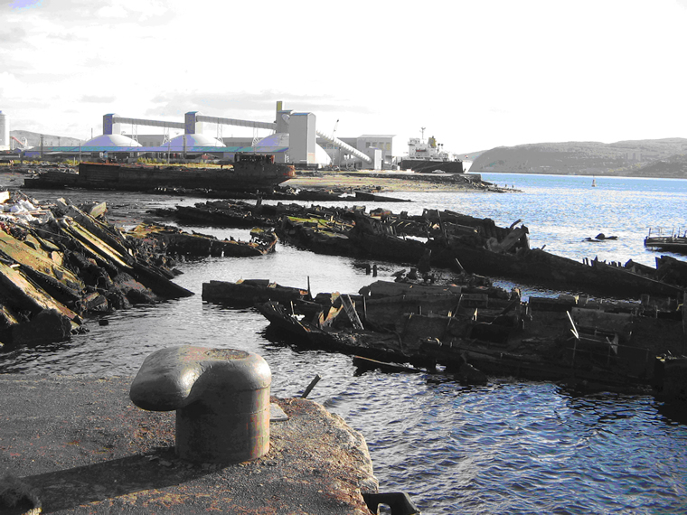
Figure 10. Unauthorized Salvage Shipyard as Environmental Hotspot

- Illegal shipwreck dump sites are hotbeds of high environmental risks, a significant source of polluting water and bottom sediment with oil products, heavy metals and persistent organic pollutants. In some cases the dump sites represent a serious navigational hazard. The shipwreck dump sites limit the economic use of coastal areas (i.e. development of coastal fisheries, revival of coastal communities, aquaculture farming, etc.).
- High concentrations of pollutants in bottom sediments of the bay are, in turn, a source of secondary water pollution causing dramatic deterioration of the entire bay ecosystem.
- Based on the analysis of pollutants in the sediments of the southern bend of Kola Bay and on the substantial percentage of pollutants in the mud water one can conclude that the negative trend will continue or even escalate.
- Contamination of some coastal sections of the Kola Bay bed (the ports water areas, shipyards, the Northern Navy bases, shipwreck dump sites, etc.) has reached such concentrations that it is time to develop a special cleanup project.
- The 2007 monitoring studies showed that it was necessary to dredge and dispose of not only the highly contaminated silty soil sediments but also sand sediments (at the study planning stage it was assumed that the sea currents washed out from the latter most pollutants and the highest percentage of pollutants was expected to be only found in silty soils).
- The environmental state of the bay is such that it could barely cope with pollution through the bay’s natural self-purifying capacity (currents, tides, river runoff). If this capacity is overstretched, an ever increasing load may lead to the establishment of areas of environmental hazard. In this context, it is of particular importance to start developing the Kola Bay Integrated Coastal Zone Management Program (ICZMP) covering all the aspects of natural resources management and environmental protection in the bay.
- As it is, Kola Bay is a "hot spot" for the entire Barents region, and the geological conditions - it is located in the actual seismic zone - increase many times the risks of technological hazards.
The Concept of the Technical Project on Pollution Abatement in Kola Bay and Cleanup of Kola Bay from Highly Polluted Sediments was proposed based on the results of the Pilot Project. It features the following components:
The project for cleaning up the southern bend of Kola Bay from heavily contaminated sediments should be developed with the aim of reducing secondary contamination of the bay waters and, accordingly, of reducing export of pollutants into the Barents Sea.
The project should include not only the organizational and technical activities related to dredging the sediments, but also a set of activities for the disposal of dredged soils.
When developing the Kola Bay bed cleanup project, care must be taken to consider the following main aspects:
- Assessing the hazard class of soils to be dredged;
- Dewatering the dredged soils on the temporary storage sites;
- Methods of recycling or burial of the dredged soils depending on the content of the most hazardous pollutants;
The Kola Bay bed should be cleaned from heavily contaminated sediments within the projected boundaries by using a pipeline dredger or chain-and-bucket dredger. The slurry should be transported in a barge or through a slurry pipeline to a temporary storage site for dewatering and waste water clarification.
Given the volume of the contaminated bottom soil to be removed, the cleanup works should be carried out in sequences. The performance of each sequence can be based on the design capacity of the depositing sites, boundaries of the work sites, and the dredger operation schedule as agreed upon with its owner.
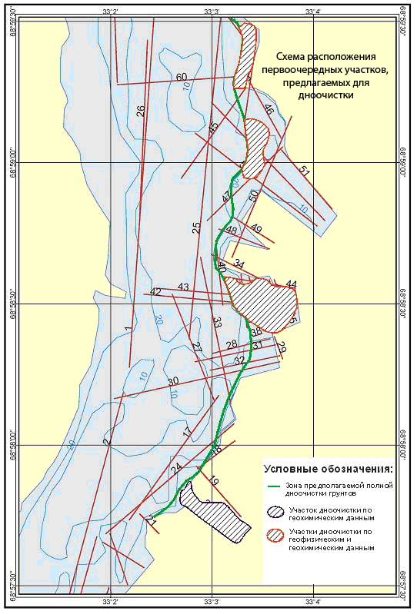
Figure 11. Layout of Seafloor Areas for Priority Cleanup
Temporary dump sites for the contaminated slurry could be located in coastal areas in the near vicinity to Kola Bay. Given the amount of the proposed work, the size of the water area, the navigation-related limitations, and other factors, several land plots for slurry dump sites should be allocated. Optimally, the sites should be located at approximately equal distances from each other, in accordance with the design distance for the transportation of slurry to the point of discharge for a specific dredge. Otherwise it would be necessary to include additional costs of physical and technical resources for the organization of the booster stations, barges, movements of a hopper dredger, etc.
The project must provide for diving or instrumentation (for instance, sonar) survey of the bay bed to identify underwater obstacles and the size of sunken matters. Just before dredging, works should be carried out to remove the identified large items (sized more than 1 m in any dimension) from the bay bed.
The Project should have a separate section to review and study a sediment dredging technology in the shipwreck dump locations. The Project should design and propose a technology for cleaning Kola Bay from sunk vessels and ships/vessels abandoned at drying. In each case, the technology of cleaning the bay from vessels must be determined taking into account the specific conditions:
- The location of the vessel (the distance from the shore, depth);
- Availability of sites to arrange the technological process for the initial disposal works;
- Vessels lifting and disposal methods;
The project should provide for modern methods of cutting vessels underwater into large sections, as well as methods to reduce the pollution of the surrounding waters during the salvage operations.

2.5. Developing Bioremediation Technology for the Cleanup the Oil-Contaminated Onshore Areas in the Arctic

The Project Goal was to (i) develop bioremediation technology for the cleanup the oil-contaminated onshore areas that could be applied in both the Russian and foreign areas in the Arctic; and (ii) disseminate successful experience of the Project.

The Project was implemented by Limited Liability Company "NavEcoservis" (OOO "NavEks").

The Project Duration : 01 July 2008 - 16 June 2009;

The Project Activities

The following activities were carried out to meet the Project goal:

- Analysis of the Russian and international experience in bioremediation of soils polluted with oil products at low temperatures;
- Selection of a bioremediation site and equipment;
- Field studies and laboratory essay of the samples;
- Review of the sample laboratory essays to identify the best types of biological products and their application methods for different types of oil products;
- Review of the results and development of the draft Guidelines for Bioremediation of Oil-Contaminated Soils in the Arctic;
- Preparing and holding workshop to discuss the results, draft Guidelines and dissemination of best practices for Bioremediation of Oil-Contaminated Soils in the Arctic.

The Project Outcomes

- The soil texture, which is characteristic of northern latitudes, is neither toxic nor pathogenic;
- The soils, that are the most typical of northern latitudes, have low biogenic levels and as such they have very low self-purification capacity;
- It was noted that the soil natural microflora demonstrated resistance to the lowering of temperature;
- Activation of the native flora can trigger a positive effect only where contamination levels are low (1-2%);
- In the main section of the remediation site, the biological product "Roder" was the best performer (4,5-5,3%) in the treatment of mazut contaminated soil, DEVOROIL performed best in the treatment of diesel fuel contaminated soil (4,8-5,9%), while Mikrozim (tm) «PETRO rub" and "Roder" did the best job in the treatment of oil contaminated soils (6,7%).
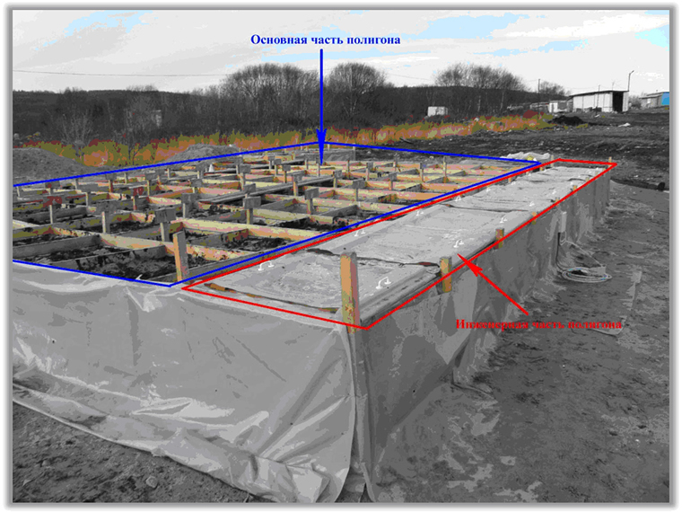 Figure 12. Overview of the Site

- In the engineering section of the bioremediation site, because of the constant above-zero temperature of the soil, the biological products demonstrated a higher degree of decomposition of petroleum products as compared with the main section. The best result in the treatment of soil from fuel oil and diesel fuel was shown by "Mikrozim (tm) “PETRO rub", while DEVOROIL worked best on oil.
- In the Arctic conditions, microbial agents are more effective as compared with agricultural method of remediation.
- Biological products have a positive enhancing effect on the biological activity of soil and, consequently, accelerate decomposition of oil spills;
- Pre-activation of biological products is recommended (preparation of working suspensions), reducing the period of bacteria activation in the soil;
- The soil peat serves as: (i) a natural sorbent agent, which reduces the penetration of oil into the soil; (ii) water-holding substance, supporting the soil humidity levels required for bacteria; and (iii) natural organic fertilizer, contributing to the intensification of remediation in the soil;
- Application rates of fertilizers and biological products are to be strictly calculated and controlled since excessive doses of mineral fertilizers cause soil acidification and this reduces the remediation capacity of contaminated soil substrates.
- It is important to maintain the necessary (40-70%) soil moisture, since soil overwetting can have a negative effect on soil phytoremediation.
- Soil aeration (loosening, milling, etc.) contributes to the uniform distribution of hydrocarbon-oxidizing microorganisms within soil, to aeration and, as a result, to еру intensification of oil biodegradation;
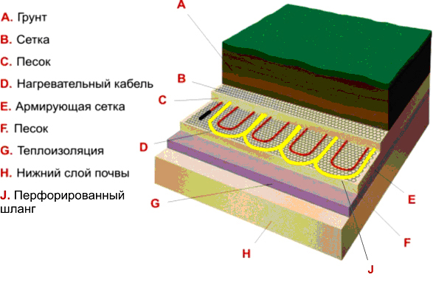
Figure 13. Layout of Soil Heating and Aeration System

- If it is no possible to do aeration by loosening or milling (permafrost is very close to the works site, of the remediation area can not be accessed by machinery), in addition to biological products, we recommend that natural sorbents (peat, sawdust, moss, etc.) be applied into the soil.
- Biological products are most effective at above-zero temperatures.
- The microbiological analysis suggests that bacteria keep on working as temperatures go down even if soil freezes. However, their activity decreases as soil temperature goes down.
- It is recommended to use phytoremediation phase at the final stage of bioremediation (seeding oil pollution resistant plants).

The results of the studies suggest that bioremediation of oil-contaminated soils in the Arctic is a promising method. This conclusion was also confirmed by the project outcomes meeting, which was held on June 16, 2009 in the Murmansk Oblast Committee of Natural Resources Management and Ecology.
One of the main achievements of this work is the application of special technologies and engineering solutions to bioremediation, enabling the continuation of the oil products biodegradation process throughout the calendar year.
The experiment proved that it was possible to use biological products in the Arctic.
The limited period of the studies did not permit any final or unequivocal conclusions about advantages of this or that biological product as applicable to a type of pollution in the Arctic conditions. It is also rather difficult to determine deadline for the completion of the bioremediation process full cycle. Based on the results, one may suggest that the soil remediation process at the remediation site may take from two to four and a half years depending on the technologies applied and provided all the specifications for the use of biological products and soil remediation process in the Arctic conditions are complied with (Figure 15).
Phytoremediation should be the final stage of biological remediation. This stage include the following steps: (i) selecting remediation grass species; (ii) calculating seeding rates; (iii) seeding and monitoring germinating capacity and growth of the grass. Depending on the contamination levels and climatic conditions, there might be a need in overseeding.
The existing phytoremediation methods could remediate soils till they reach the permissible residual concentrations (PRC) for oil and oil products.
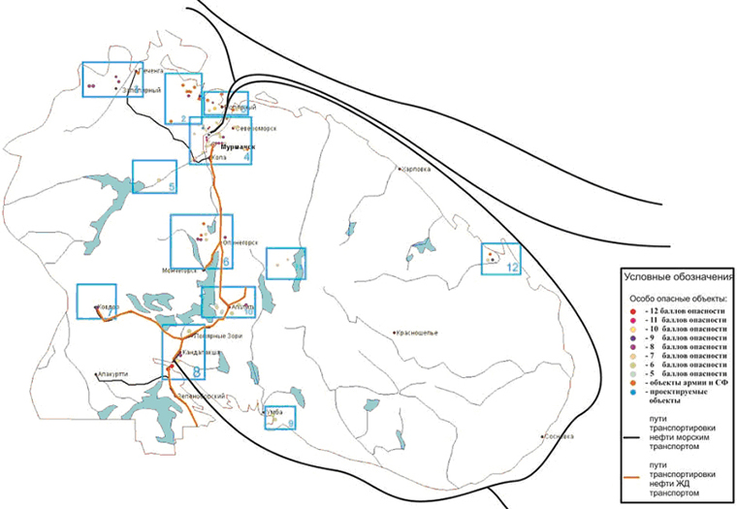
Figure 14. Map of Environmentally Hazardous Facilities in Murmansk Oblast and Oil and Oil Products Transportation Routes
Establishing PRC for soils in Murmansk Oblast was one of the issues that was raised when discussing remediation practice in other constituent subjects of the Russian Federation. With no PRC, one has to remediate soil till there is zero concentration of oil or oil products in the soil and this poses a problem in the Arctic conditions.
The draft "Guidelines for Bioremediation of Oil-Contaminated Soils in the Arctic” is the first such document, which was adopted by Murmansk Oblast to guide bioremediation processes, including approaches based on technological innovations.
In furthering the draft Guidelines on the basis of similar practice in the Komi Republic and other regions, care should be taken to consider both oil spill response and oil spill management measures until the remediated lands are back to the full economic cycle.

2.6. Cleanup of the Bay of Tiksi Seafloor from Sunken Logs and Shipwrecks Pilot Project

The Project Goal was to protect the biosphere in the marine and coastal zone of the Bay of Tiksi and Gulf of Bulunkan from man-induced pollution. The Project was to cleanup the coastal zone of the Bay of Tiksi and Gulf of Bulunkan from sunken timber and to prepare 5 sunken vessels for salvaging.

The Project was implemented by Open Joint Stock Company “Tiksi Sea Port”. The Project also contracted the Federal State Organization "The State Nature Reserve Ust’ - Lensky" to do the pre-cleanup and post cleanup assessment of the pollution levels of the Bay of Tiksi analysis of the environmental status of the Bay of Tiksi and the Gulf of Bulunkan.

The Project Duration: 01 July 2008 - 08 August 2009;

The Project Activities

- The Project analyzed the existing domestic and foreign practice in the water area cleanup operations, prepared the design documentation, and trained the Port technical personnel in the safety and quality of the cleanup operations in the bay. The Project also carried out the depreservation, repair and restoration works on small vessels, lifting equipment and small tools and equipment. The Project assessed the pre-cleanup pollution levels in the Bay of Tiksi.

- The seafloor of the Gulf of Bulunkan was dredged with a grappler installed on the floating crane to lift the sunken logs, load them onto a pontoon or seaborne barge, and transport the logs to the onshore offloading point to be graded and banked.

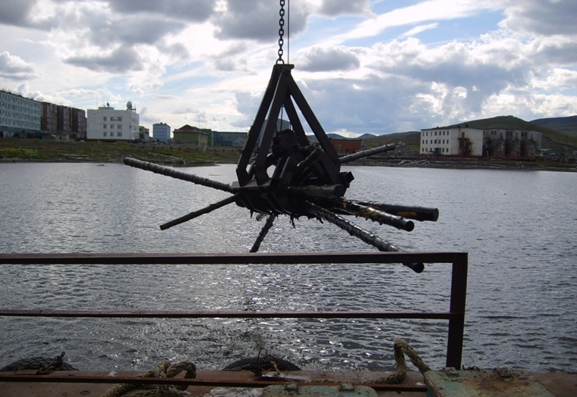
Figure 15. Salvaging Timber from Tiksi Bay Seafloor

- The preparatory work on the hulls of the wrecks was carried out including: (i) diving survey; (ii) for salvaging purposes, work was done to fix damaged areas of the sunken vessel hulls by establishing five water-tight patches; (iii) a methodology for lifting the wrecks was identified and approved.
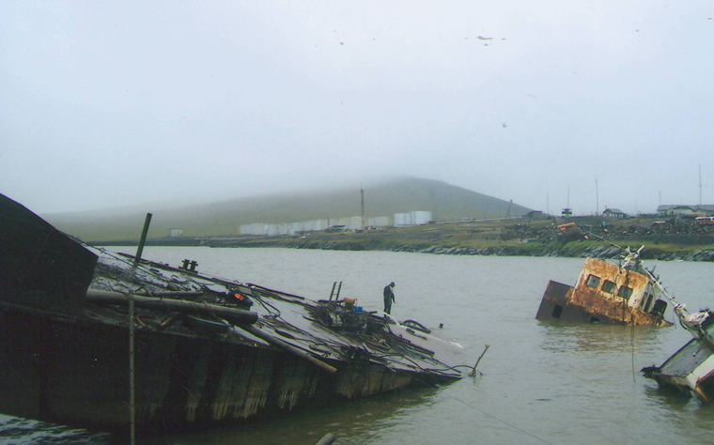
Figure 16. Shipwrecks in Tiksi Bay

- One more study of the water quality in the Bay of Tiksi and the Gulf of Bulunkan was carried out. Following this, a comparative analysis of the water contamination before and after the cleanup, as well as assessment of the environmental status of the bay waters was carried out.

The Main Outcomes

Prior to the cleanup of the seafloor in the Gulf of Bulunkan (1 August 2008), the Project carried out hydrobiological monitoring of the zooplankton and zoobenthos in the waters of Bay of Tiksi and the Gulf of Bulunkan. The water pollution levels (water quality based on hydrobiological indicators) was assessed through the use of the Goodnight - Wheatley index and Woodywiss F. Biotic index for water zooplankton and zoobenthos and the oligohet ratio to the overall number of zoobenthos organisms.

The long-term monitoring showed that the Gulf of Bulunkan as compared to the Bay of Tiksi is characterized by lower values of abundance, biomass and species composition of zooplankton (9 species versus 20). This is due to man-induced pollution, low oxygen content in winter and high levels of sulphides and chlorides. The species composition of blue-green and green algae is poor, dominated by diotom species of algae. The scientific study of the samples of zooplankton and zoobenthos showed that water is of moderate contamination. The water saprobity class was defined as mezasaprobity, i.e. there is pollution.

Environmental degradation in the shallow waters of the Gulf of Bulunkan as compared to the Bay of Tiksi was caused by a combination of various detrimental factors. The biggest contribution to the water pollution is phenols accumulating from rotting sunken logs and wood residues. According to the characteristics of the bottom-dwelling biocommunity obtained during monitoring (August to October), all the Gulf samples showed that water (water purity grade) was moderately polluted, while water in the Bay of Tiksi was clean. In other words, the quality of water in the Gulf of Bulunkan was worse than water quality in the open water area of the Bay.

Entering the coastal waters, pollutants have a repelling impact on fish and change the conditions of fish feeding, wintering and spawning. They also contribute to high concentrations of fish shoals within a limited area, while keeping the fish from the fodder organisms, making it difficult to use the feeding resources and reducing the biological productivity of the water body as a whole.

Direct poisoning of water with toxic pollutants and industrial waste, reduced aeration of the water body due to the freezing up or man-induced contamination with oxidizing organic pollutants, in particular caused by the accumulation of decaying vegetation, timber or development of toxic microorganisms may generate fish kill conditions or kill fish outright because of insufficient amount of oxygen in the water of the Gulf of Bulunkan. Water is especially oxygen-poor in winter, with ice cover growing thicker. The thicker the ice cap is the less the amount of water in the bay and this contributes to the concentration of organic, biogenic, and polluting substances in the bay. Also, the Lena River carries less fresh oxygen-rich water into the Bay of Tiksi and Gulf of Bulunkan. Decomposition and decaying of the sunken logs intensifies generation of pollutants and uptake of oxygen.

The purpose of the cleanup operations was to determine how strong will be the effect of the effort to trawl out the decaying timber in one season on the quality of the Bay water in future. The 2008 seafloor trawling was launched in the shore area of the southeastern part of the Bay. In 2009, trawling continued in the shore area 400 m wide, in the western part of the Bay up to the Cape of Ice (the works were completed on 8 August 2009).

The seafloor cleanup operations (the diagram is attached) were carried out in an area of over 500,000 m2 (0.56 km2). All in all, 41 shifts produced 1,900 m3 of logs lifted from the seafloor. Most of it (over 80%) was rotten, causing biological contamination of water, in particular with phenols. In addition, the cleanup operations lifted from the seafloor 22 tons of steel wire, wire ropes and chains taken onshore for recycling.

We may calculate accumulation of the decaying timber per square meter of the seafloor by dividing the amount of the timber lifted (1,900 m3) by the seafloor area cleaned up (560,000 m2) to receive 0.0034 m3/m2.

Thus, in order to lift 1 m3 of logs from the seafloor, it will be necessary to trawl about 300 m2 (294 m3 is an area of 20*15 m). This will require up to 100 cycles of the lift-lower movements of the clamshell. In other words, the seafloor cleanup operations were very intensive.

Upon the completion of the seafloor cleanup operation, the Project carried out another hydrobiological and hydrochemical analysis of the water samples taken at the site of the cleanup operation in the Gulf of Bulunkan, as well as at the site of the operations in the Bay of Tiksi. The comparative analysis against the 2008 initial studies showed improvement in the water quality demonstrated clearly by an overall increase in the density of communities and biomass of both zoobenthos and zooplankton. The analysis also found that after the cleanup the bay seafloor amount of pollutants, in particular phenols, was reduced due the reduction in the amount of decaying wood, the main source of phenols.

CONCLUSIONS

- The trawling of the seafloor in the Gulf of Bulunkan and the good results of the water quality analysis following the cleanup operations indicate that the clamshell trawling and the respective machines and equipment were the right choice.

- The quality of work suggests that it would be possible to reduce time and complexity of work concerning the lifting and disposal of wrecks.

- The improved water quality, having resulted in an overall increase in the density of communities and biomass of zoobenthos and zooplankton only after one season of the cleanup operations suggests that such work should also be continued at the second phase of the pilot project.

- The future expansion of the cleanup seafloor area towards the central part of the Gulf of Bulunkan would increase the amount of the decaying timber to be lifted from the seafloor to 2,500 – 3,000 cu. meters.

- Future cleanup operations will lead to significant improvements in the environmental status of the Bay of Tiksi and the Gulf of Bulunkan basins.

- Providing local people with firewood from the timber so lifted will help conserve forests since there will be no need to fell trees. The local population used to gather timber for construction and firewood from rafts crashed by bad weather but after the termination of the timber rafting people started cutting down larger quantities of trees in the forest-tundra.

- Intensive decaying of the sunken logs (more than eighty percent of the total amount of the sunken logs) leads to dangerous and toxic chemical contamination of water. Chemical contamination of water has a negative impact on wintering, feeding and spawning of the most valuable commercial species of the Arctic fish requiring intensification of the cleanup operations.

- Developed and tested at the port, the clamshell trawling method can be applied in other Arctic regions in shallow fisheries and "fattening" water bodies.

- As a result of the preparatory work on the wrecks they are ready to be lifted and recycled at Phase II of the Project

2.7. Pilot Project: Environmental Remediation of the Former Military Site near Pokrovskoye Settlement, Onezhsky Rayon, Archangelsk Oblast of the Russian Federation

The purpose of this Project was to demonstrate a cost-efficient methodology of environmental remediation of abandoned oil-contaminated military sites prior to the transfer of such sites to civil use. The Project was to disestablish the abandoned oil storage located in a 1,000 m2 pit near the river running into Onega Lake of the White Sea.

The Project was implemented by OOO GORST in cooperation with the specialized organization “OOO Ecopromservice”.

The Project Duration 2 October 2009 – 30 November 2010;

The Project Activities

1. Stage 1 of the remediation works (2009) included the following activities:
- Preparatory works;
- Collecting and loading oil products from the oil storage into the holding tank for temporary storage with EK-18 Excavator;
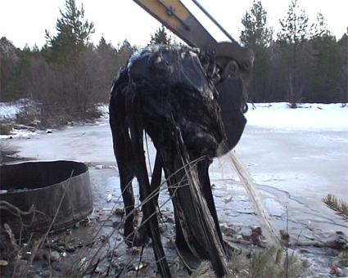
Figure 17. Collecting and Loading Oil Products from Oil Depot
- Heating the oil products locally up to 600С by using tubular electric heaters and pumping the oil products through GAZ KO-503 and KAMAZ KO-505 trucks (by using pump screens) into KAMAZ and Scania bitumen distributors;
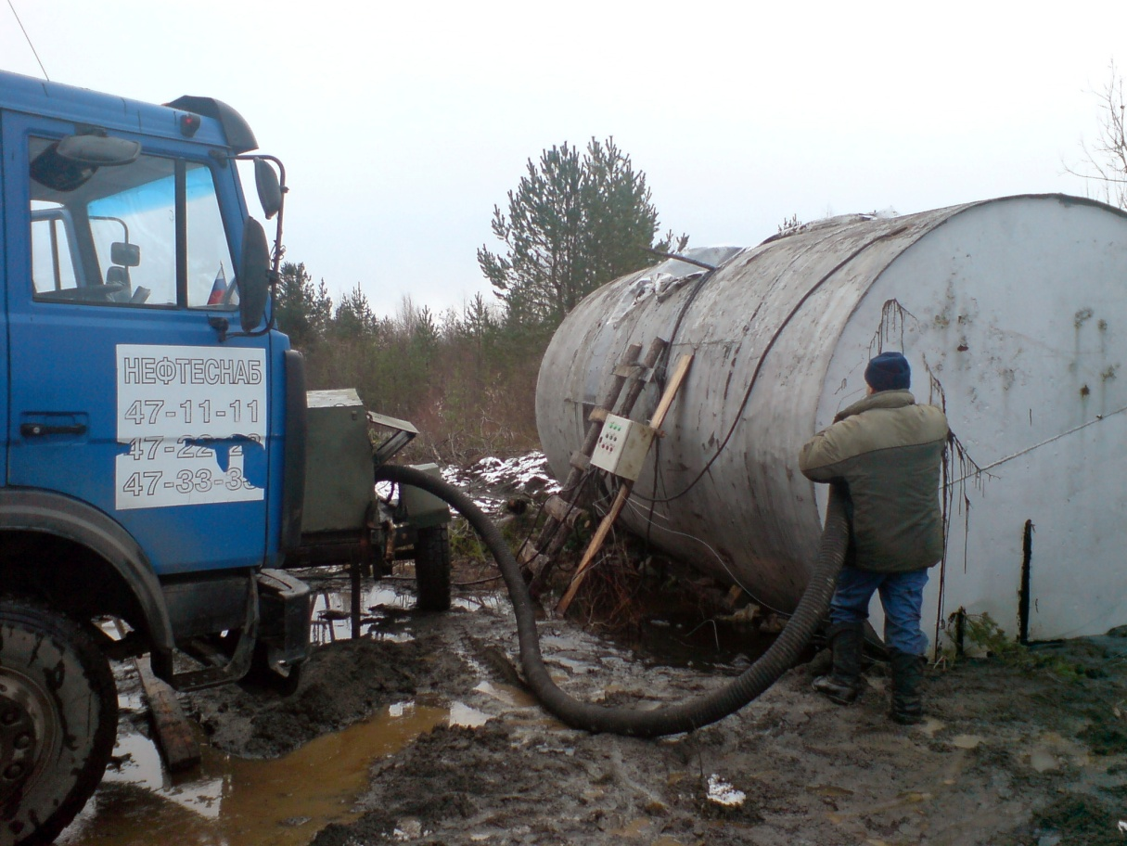
Figure 18. Pumping Oil Products
At Stage I, the Project collected and loaded into the bitumen distributors the total of 3,000 tons of oil products, which were then transferred to the specialized organization “OOO Ecopromservice” for use as secondary material resources.
2. Stage 1 of the remediation works (2009) included the following activities
- Removing 1.5 m3 of the contaminated bush from the oil storage dykes and neutralizing the bush by burning it at a Forsage-1M Installation at a temperature of 1,000 degrees;
- Removing 635 tons of poor oil products from the oil storage inner surfaces and dykes with an EK-18 excavator and placing them for temporary storage at the OOO GORST Production Facility in Onega, Archangelsk Oblast, until a neutralization decision is made;
- Removing 560 m3 (560 m3*1.65t/m3 = 924 t) of oily soil from the adjacent territory (311.1 m2) with an EK-18 excavator and neutralizing it in an UZG-1M.1,2/6.7.12 installation at a temperature of 800 – 900 degrees;
- A push-type scraper and digging tools were used to carry out land shaping on an area of 0.57 ha;
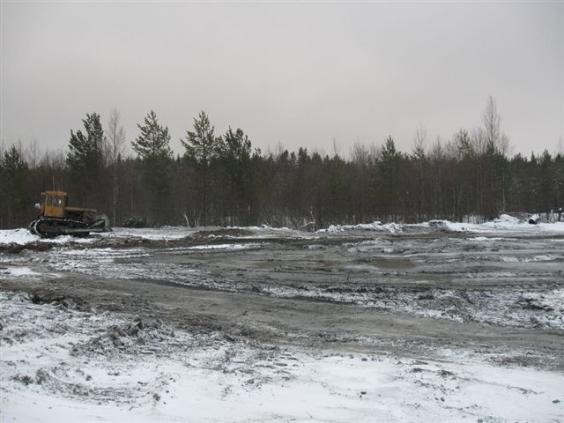
Figure 19. Overview of Oil Storage in Pokrovskoye, Onega Rayon (after completion of levelling operations)
- 113.5 kg of grass and grass mix (meadow fescue grass, timothy grass, red fescue grass) was planted on an area of 0.57 ha.

The Project Outcomes

Rehabilitating abandoned oil storages and oil-contaminated territories of abandoned military facilities and bases in the Russian Arctic brings focus on the following aspects:

- Given the climatic and geographic factors of the environment, a specific approach should be taken when making a remediation decision for such facilities;

- A decision should be made as to whether it will be practical to use oil sludge or substandard oil products as recyclables and to transport them to the place where these will be used;

- In the Russian Arctic, a thermal method of remediation of the oil-contaminated territories is one of the main remediation methods;

- The period from June to October is the best time to carry out remediation activities in the Russian Arctic;

The environmental remediation activities at the former military site near Pokrovskoye Settlement, Onezhsky Rayon, Archangelsk Oblast, cleaned up these land areas from oil products. The total of the cleaned up area was 0.57 ha (5, 667 m2).

Therefore, these lands may be used for the purposes of forest management - by the types of forest plantations - or for constructing buildings, structures, and facilities for manufacturing or other similar purposes on these lands.

2.8. Pilot Project: Development of technology for cleaning up the Arctic decommissioned sites of the Russian Ministry of Defense from hazardous waste as demonstrated on Alexandra Island of Franz Josef Land Archipelago

The Project Goal was to gain the technology application experience to be replicated at other decommissioned facilities and on sites of the Russian Ministry of Defense. Under the Project implementation it was necessary to select and test modern technologies for the utilization of drums in the arctic context by using innovative solutions for a large amount of drums (up to 1,000) of different years of manufacture and with different contents. Foreseeing the presence of PCB sources and heavy metal pollution on the island, it was necessary to identify and map such sources, select samples of soils and technical liquids to be found in the process equipment. The desk study was to be carried out to assess the real threat of environmental pollution and to propose methods for containment or liquidation of the pollution sources.

The Project was implemented by the non-profit organization "Polar Research Foundation (NO "Polar Foundation”) which took into account the results of similar works carried out on Franz-Josef Land in 2007-2009.

The Project Implementation Period: 01 December 2009 - 30 November 2010

The Project Activities

Stage I: Identifying and mapping sources of hazardous pollutions. Taking and analyzing samples to better locate the pollution sources.

  - Based on the 2007 data, selecting the cleanup site and developing the program for additional assessment of the contamination levels of the soils and process fluids on the sites selected;
  - Identifying and mapping the hazardous pollution sources on the Alexandra Land sites selected for the cleanup activities including sampling of soils and process fluids; locating capacitor assemblies and transformers with “sovtol” or other PCB-containing fillers within the radar equipment;
  - Carrying out chemical and analytical analysis of the soil and process fluids samples with a special focus on the determination of surfactants, heavy metals, and chlorine organic compounds;
  - Processing the results of the field works and sample analysis in the office; plotting the scale 1:1000 map for various areas to justify the selection of the experimental site;

Stage II: Developing the Technology and Procuring Equipment

  - Reviewing the existing domestic and foreign experience in cleaning up the sites of abandoned military facilities from drums with residual lubricants, fuels, PCB; preparing design documents;
  - Selecting the technological cycle for drum utilization and carrying out preliminary manufacturer’s testing of the equipment by using drums before shipping the equipment to Franz-Josef Land Archipelago; developing the technological project for (i) a large-scale utilization of drums containing highly hazardous substances; (ii) safe elimination of the contents, and (iii) compacting of the drums and shipping them to the reception facility in Archangelsk;
  - Developing the process design for handling heavy metals containing wastes, process equipment and its components;
  - Developing the process design for the conservation of equipment with sovtol and other PCB-containing fluids;
  - Procuring and testing the required process equipment;
  - Initiating and preparing the personnel including training for hazardous substances handling; safety briefings;
  - Obtaining the required permits from the corresponding authorities for sea carriage of the drums and their storage in Archangelsk, signing agreements with enterprises that committed to accept the compacted drums for their safe utilization;
  - Preparing the work programs for Stage III of the Project;

Stage III: Eliminating or Conserving the Sources of Highly Hazardous Pollutants

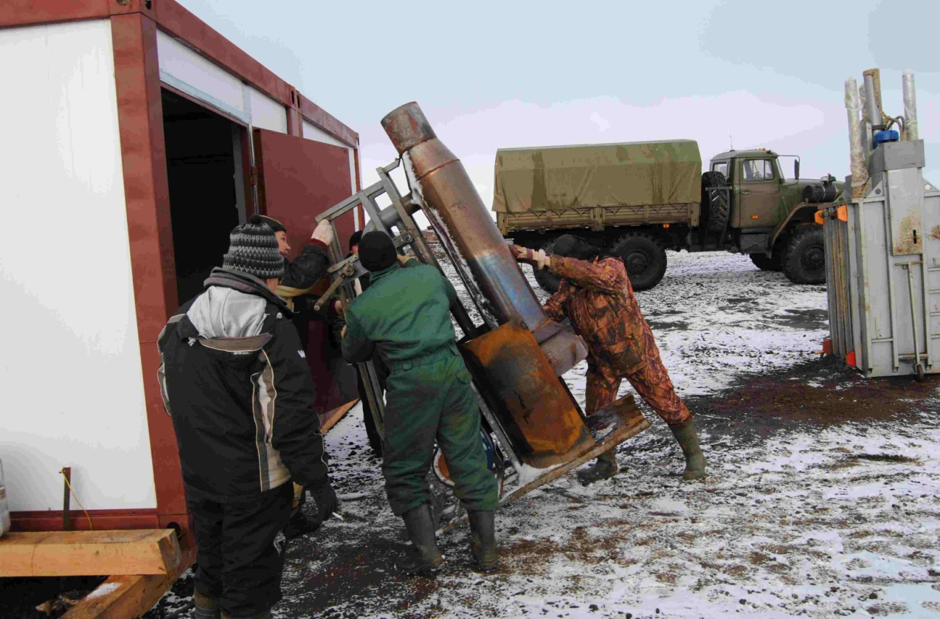
Figure 20. Installing Fuel Burnout Furnace and Steel Drum Compacting Press

  - Delivering the equipment and personnel to the work site, mobilizing the equipment and preparing it for work, carrying out the required civil engineering works;
  - Collecting drums with residual fuel and lubricants from the selected area; taking the drums to the cleaning site and cleaning the drums; draining the residual fuel and lubricants into the specially prepared tanks; where required, thawing up the drums by applying the technology specially developed for the purpose; testing various technologies for the final cleansing of the drums from the residual fuels and lubricants (flushing, burning out, etc.); cleansing the drums from the residual fuels, lubricants and hazardous pollutants by applying the selected technologies and controlling hazardous emissions; cutting and compacting empty drums (not less than 1,000 drums); packing the pressed drums and preparing them for transportation;
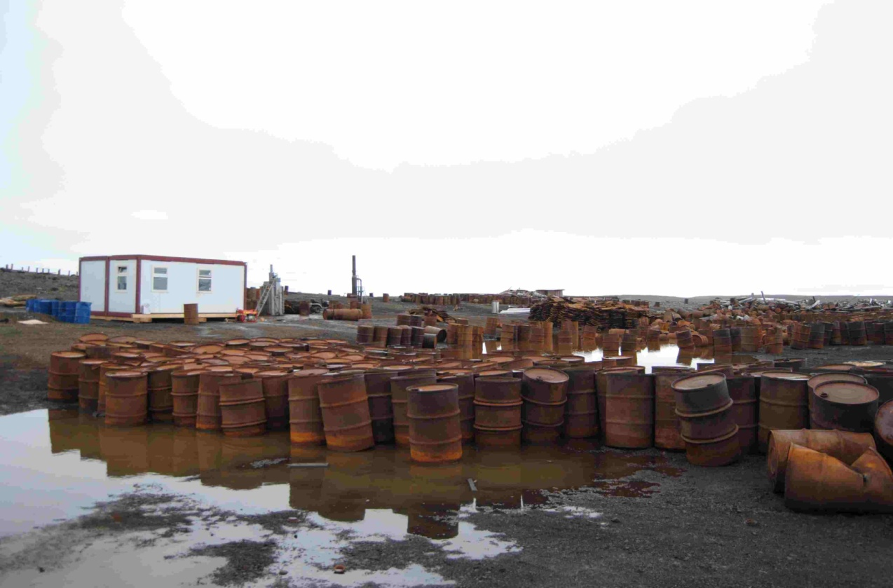
Figure 21. Drums Prepared for Cleanup and Pressing
  - Taking the pressed drums to the vessel, and transferring them an Archangelsk recycler to for safe utilization;
  - Experimental mothballing of the PCB-containing equipment;
  - Experimental conservation of the heavy metal containing waste;
  - Taking samples at the work site to analyze them for soil and water contamination levels and to monitor concentration patterns over time;
  - Developing TOR for surveys and preparation of the Project for large-scale cleanup of the decommissioned sites of the Russian Ministry of Defense on Alexandra Island within the Franz Josef Land Archipelago;
  - Preparing the concluding report in Russian and English with a detailed description of the full technological cycle concerning drum utilization and all the other completed works supported by recommendations for cleaning up the Franz-Josef Land Archipelago from drums and for neutralizing waste containing PCB, heavy metals and oil products;

The Project Outcomes

The Project resulted in a package of proposals for a large-scale project to carry out complete cleanup of Alexandra’s Island from empty drums and abandoned military equipment in accordance with a variety of options.

The Pilot Project developed and tested a technology for cleaning up polluted areas in the high Arctic from hazardous wastes as demonstrated by the works carried out on the experimental site located within the abandoned military facility of the Russian Ministry of Defense on Alexandra’s Island.
During Stage I of the Pilot Project, works were carried out to additionally study the contaminated sections of the Alexandra’s Island of the Franz-Josef Land Archipelago aimed at selecting an experimental work site. Out of five areas surveyed, a section of the fuel and lubricants storage located in Severnaya Bay was selected as an experimental cleanup site. The additional survey found drums with motor oil and residual waste fluid containing 2-4 percent of PCB. This was a proof of the 2007 assumption that the island had a permanent PCB pollution source requiring a lot of caution in the carrying out of the works under the Pilot Project.
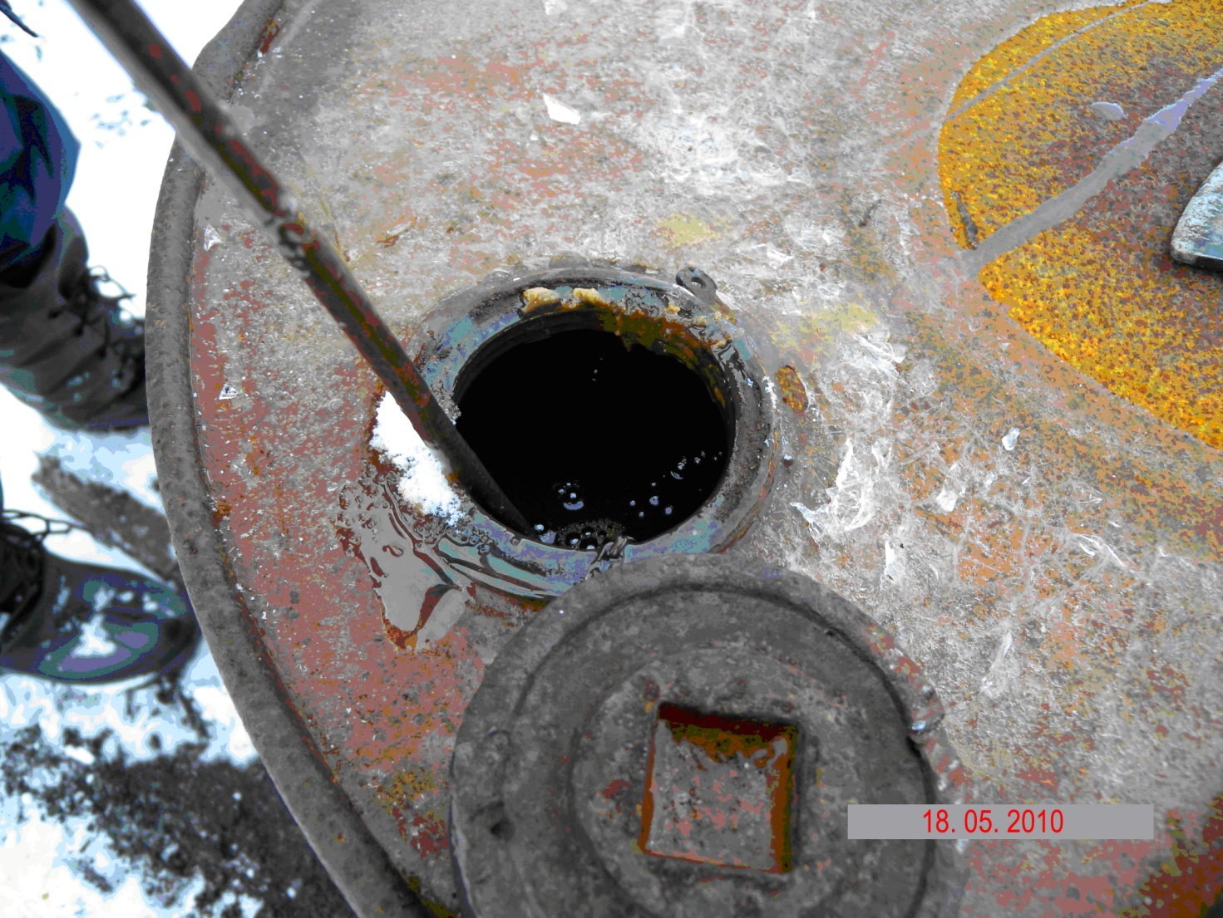
Figure 22. Testing Motor Oil Drums for PCB
At Stage II of the Pilot Project, a process design was prepared for (i) large-scale utilization of the drums containing highly hazardous substances; (ii) safe elimination of the contents, and (iii) compacting of the drums and shipping them to the reception facility in Archangelsk. In accordance with the Project, a work program was prepared to ensure implementation of Stage III of the Pilot Project, and the needed equipment, components and consumables were procured.
In accordance with the Contractor’s request, Tochnaya Mechanika Works – based on the experience of the 2007 activities – upgraded a 26-t TM-22TPF hydraulic press and successfully tested the compacting of thick wall steel drums with walls 1.5 mm thick.
The field team took training in hazardous waste training at ANO “Center for Training and Design Concerning Industrial Waste Handling”. During the field works, they delivered safety briefing to the technical personnel of the field team and supervised their operations.
Stage III of the Pilot Project implemented experimental utilization of a large quantity of 200 l fuel and lubricant drums of different ages that were stored without any control within the abandoned military facility of the Russian Ministry of Defense on Alexandra’s Island.
The procured equipment was delivered on the archipelago on board of the Michael Somov Research Vessel and installed on the work site near the fuel and lubricant storage in Severnaya Bay. A MI-8T helicopter was used for this purpose.
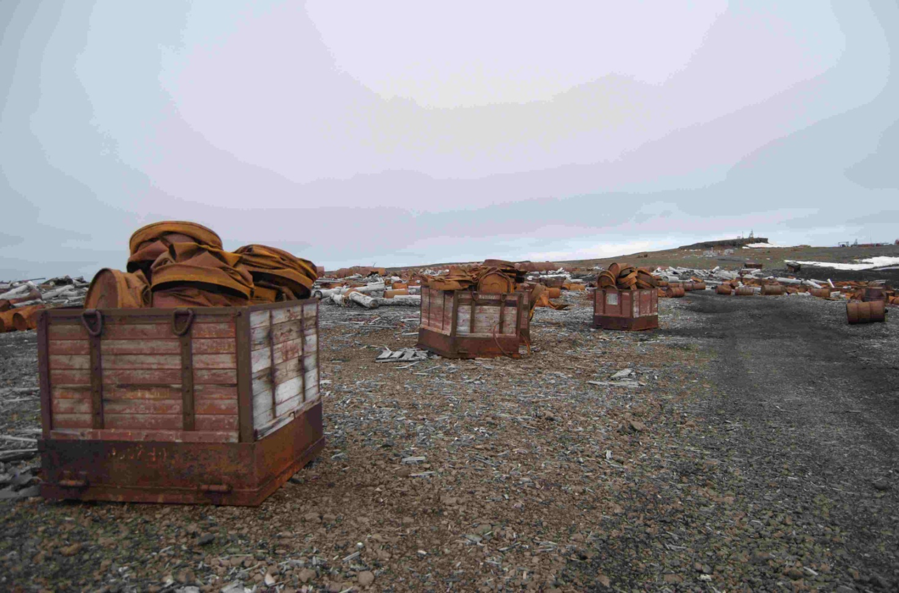
Figure 23. Fuel Drums Pressed and Prepared for Transportation
Stage III cleansed and compacted 1,000 steel drums (200 l drums) of different ages including 87 drums with residual kerosene and 78 drums with residual diesel fuel.
The process schemes applied turned out to be rather effective. Within a rather short period of time, the lean field team managed to select, drain, remove the residual fuel and lubricants, compact them with the hydraulic press and take to the mainland 1,000 fuel and lubricant drums, therefore having launched the actual cleanup of the archipelago.
The accompanying measurements of the air contamination levels showed that the high temperature burning out of the residual fuel and lubricants from the drums by using Fakel-1M burners generated little pollution of the surrounding environment. At the same time, the drums were completely cleaned from the residual fuel and lubricants.
The Pilot Project works showed that this technology, which was developed and implemented under the Project, could serve as a good basis for large-scale disposal of hydrocarbon pollution sources in the Franz-Josef Land Archipelago provided the process modification proposals have been taken into account. The technology could also be further used in other regions of the high Arctic.
A special focus should be on fluids containing highly hazardous substances, in particular PCB. It is unlikely, that in the high Arctic, it would be possible to establish a certified PCB destruction facility. According to NO “Polar Foundation”, the best option would be to develop and use plants that bring down a hazard class of wastes in order to transport them to the mainland for utilization.

2.9. Pilot project: Cleanup of tiksi bay seafloor from sunken logs and wrecks. Phase 2

The Project Goal was to protect the biosphere in the marine and coastal zone of Tiksi Bay and the Gulf of Bulunkan from man-induced pollution. This Pilot Project was aimed at completing the cleanup of the seafloor from sunken timber and wrecks of five ships in water area of Tiksi Bay as a follow up of the works carried out in 2008-2009.

The Project was implemented by Open Joint Stock Company “Tiksi Sea Port”.

The Project Duration 01 December 2009 – 30 November 2010

The Project Activities

Stage 1
The seafloor was dredged to lift the sunken logs, load them onto a seaborne barge, and transport the logs, wire and cable wire to the onshore offloading point, where the dredged items were offloaded, with the logs graded, and stacked.

Stage 2
Works were carried out to lift and transport three sunken ships without violating the integrity of their hulls. The ships were floated by cleaning their decks from accumulated soil and garbage (i.e. wire, cables, etc.). Diving operations were also carried out to cut out technological openings for the holds to be dried. Water pumps were installed and water pumped out. As the ships were floated they were towed to the cutting and demolishing site.

Stage 3
Two ships, submerged near the shore, were pulled on shore with a pull winch, with their hulls cut in a step by step way. A ship was pulled out of water onto the shore, with the garbage removed. Holds were then dried up. Part of the ship was then cut out onshore to be then separated into smaller portions and transported onshore for disposal.

Stage 4
Carrying out of the “Baseline Study of Physico-Chemical Contamination of the Seafloor Sediments and Seawater in Tiksi Bay”

The Project Outcomes

In Tiksi Bay, remediation activities resulted in environmental improvement of over 100 km2 of water area and about 1 billion m3 of water mass. This will lead to health improvement of over 15,000 inhabitants of northern settlements including 5,000 representatives of small-in-numbers indigenous peoples of the North, whose main diet includes northern fish species, since fish products will be of better quality and there will be more fish for local people.

From June 15 to July 16, 2010, the seafloor of the Gulf of Bulunkan was dredged with a grappler installed on the floating crane to lift the sunken logs, load them onto a seaborne barge, and transport the logs to the onshore offloading point. The barges were towed by the VOLNA RBT harbor pusher tug. On the shore, the logs in an amount of 990 m3 were unloaded, graded and stacked. The dredging yielded positive indicators of water quality after the cleanup works.
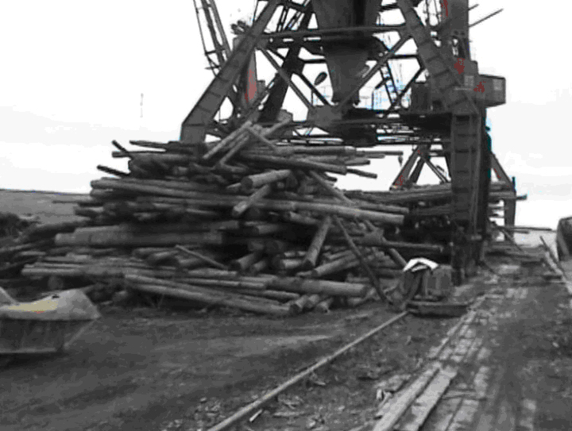
Figure 24. Sunk Timber Raised from Bulunkan Sea Floor

In August 01-31, 2010, works were carried out to lift and transport three sunken ships without violating the integrity of their hulls.
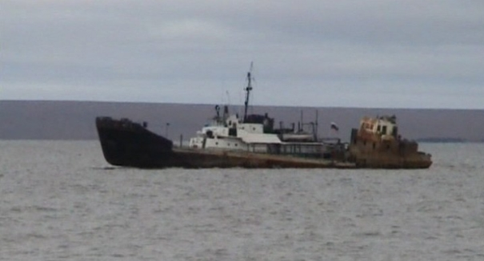
Figure 25. Transportation of Ship Lifted on Surface

The ships were floated by cleaning their decks from accumulated soil and garbage. Diving operations were also carried out to cut out technological openings for the holds to be dried. As the ships were floated they were towed to the cutting and demolishing site.

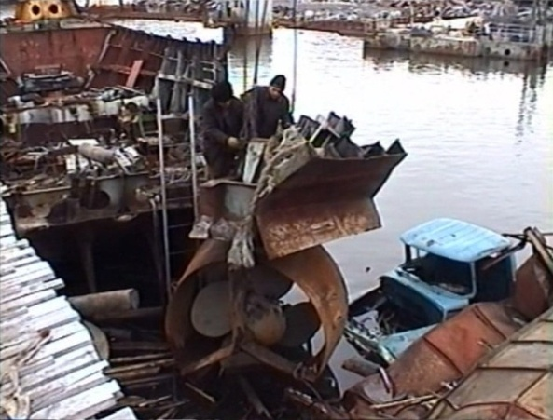
Figure 26. Cutting and Utilization of Ship Lifted from Sea Floor

In September 02-30, 2010, two ships, submerged near the shore, were pulled on shore with a pull winch, with their hulls cut in a step by step way. A ship was pulled out of water onto the shore, with the garbage removed. Holds were then dried up. Part of the ship was then cut out onshore to be then separated into smaller portions for disposal.

At stage 4, the Project entered into a contract with FGU "The State Nature Reserve Ust’ - Lensky" for the works titled “Baseline Study of Physico-Chemical Contamination of the Seafloor Sediments and Seawater in Tiksi Bay”. From the “Baseline Study of Physico-Chemical Contamination of the Seafloor Sediments and Seawater in Tiksi Bay” Report one may conclude that the cleanup operations (removal of sunken logs and ships) had positive effects on the environmental status of the water area.

The following conclusions were drawn as a result of the Pilot Project implementation:

- Intensive decaying of the sunken logs leads to dangerous and toxic chemical contamination of water. Sunken larch trees are a source of long-term accumulation of nutrients and organic matter in water. A five-year contact with water does not ensure total of leaching of biogenic matter from wood.
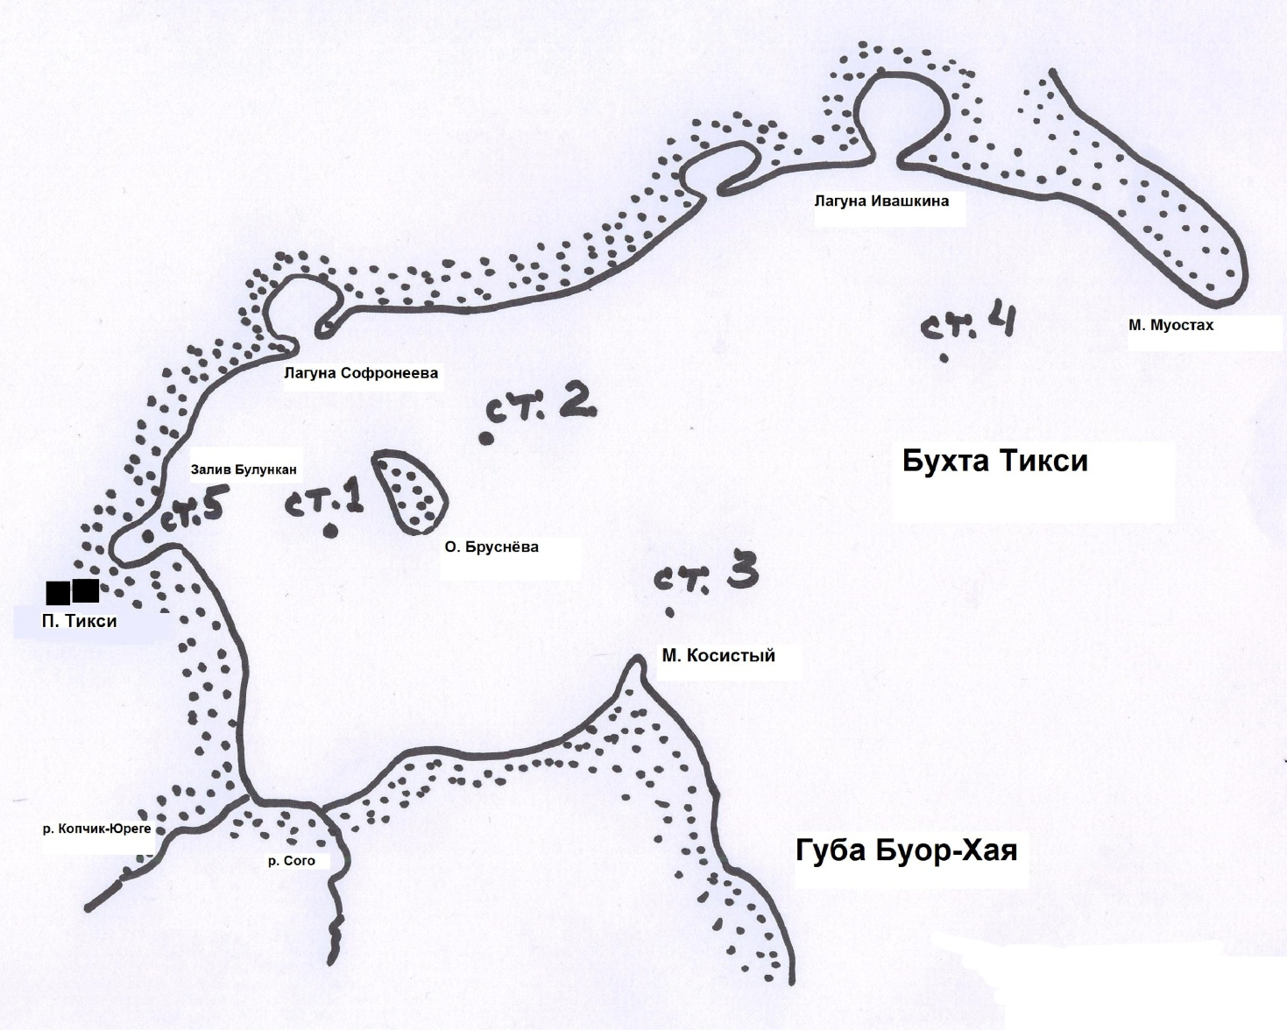Figure 27. Layout of Hydrochemical Stations in Tiksi Bay

- Chemical contamination of water has a negative impact on wintering, feeding and spawning of the most valuable commercial species of the Arctic fish. This requires not only the continuation of cleanup operations, but their intensification

- Providing local (indigenous) people with firewood from the logs so lifted will help conserve forests since there will be no need for felling forests

- Sunken wrecks pose environmental threats and could be dangerous for the local population. The works with the wrecks were carried out in accordance with the Contract and basic technologies of ship lifting and transportation without violating the integrity of the ships. The ships were dragged onshore and cut out in a staged way by separating parts of their hulls.

- From the environmental point of view, the wreck floating and lifting techniques were the right choice since they were not associated with sediment detachment and subsequent generation of vast areas of contaminated suspended matter. Suspended matter could increase concentrations of both suspended matter and pollutants accumulated in the sediments, in particular, petroleum products. This was not the case in the implementation of this contract, since the wrecks moved at a speed of smooth bottom deformation causing no breakup in the surrounding sediment mass.

- Future cleanup operations will definitely lead to significant improvements in the environmental status of the Tiksi Bay and the Gulf of Bulunkan basin

2.10. Pilot Project: Localisation and removal from a thermokarst crater of two radioisotope thermoelectric generators (RITEGs) of GONG type at the Kondratiev navigation beacon site in Ust’-Yanski Ulus of Republic of Sakha (Yakutia).

The Project Goal was to ensure radiation safety and to prevent the risk of radioactive contamination of the water areas along the Arctic coast of Ust’-Yanski Ulus by testing the methodology of identifying the lost – due to the shoreline disturbance caused by intensive coastal thermocarst processes - two RITEGs by applying geomagnetic, electric exploration and radiometric surveys, digging up both RITEGs from a thermokarst crater to the surface and preparing them for transportation and disposal.

The Project was implemented by the individual enterprise “Sell’yakhov” together with Tiksi Hydrographic Facilities (a branch of the Federal State Unitary Hydrographic Enterprise) and Federal State Unitary Research and Production Enterprise “Geology Exploration”.

The Project Duration: 30 April – 30 November 2010

The Project Activities
At the initial stage of the organizational activities for Stage I of the Project, all the required authorizations were obtained to ensure the works safety control including formal permits for these works.
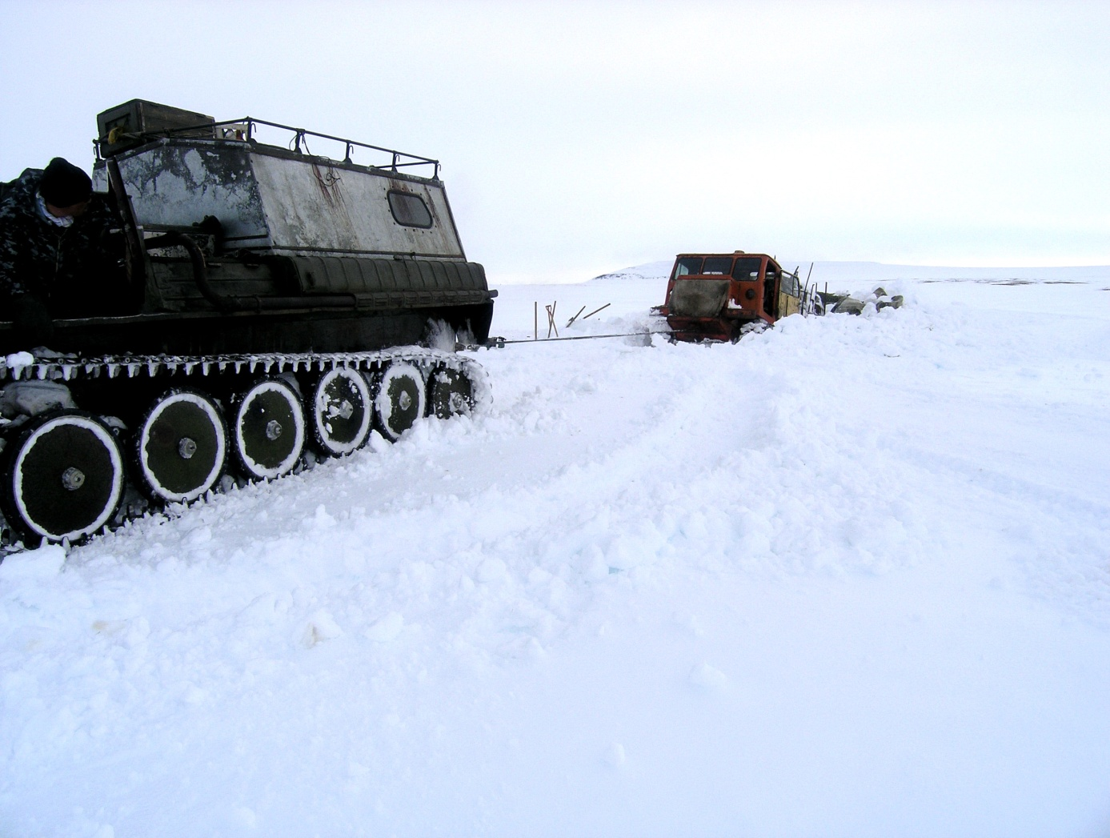
Figure 28. Cat Train on Its Way to Kondratiev Facility

A portable electric piling hoist was made to ensure soil excavation. The required tools and equipment including radio and navigation equipment were also made. From Tiksi Port to the Kondratiev site, a cat train tracked over the ice-covered the Laptev Sea to deliver workers, food products, fuel and lubricants, equipments, and materials needed to prepare the site prior to the arrival of the main team of specialists and workers. The cat train track was selected by analyzing satellite photos and experience of taking such tracks.
In accordance with TOR, Stage II of the Project included the following activities:
- A research team of specialists from FGU NPP Geological Exploration (Saint-Petersburg), workers of IP Selliahov and a representative of Tiksi Hydrographic Facilities were delivered by air to the Kondratiev site;
- Additional preparatory works were carried out. The team established a tent camp, installed a diesel generator, and constructed power supply to the tent camp and to the RITEG search area. The workers also constructed two log frames on the adjacent site, and prepared heat insulation from turf-like sea material;
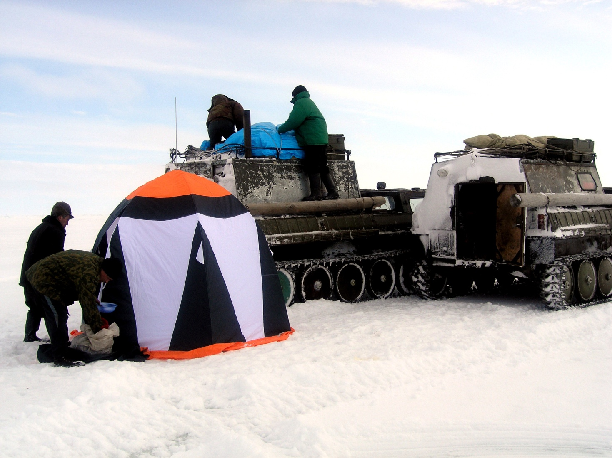
Figure 29. Tent Camp of Research Team
- The surface area of the assumed RITEG locations was measured for radiation;
- A site was prepared and cleaned to apply geophysical methods;
- Geophysical methods were used to study the location. The study identified numerous metal items that generated anomalies and violated the purity of the survey. As such anomalies were identified the source items were excavated and hollowed out. The repetitive application of this cycle (i.e. identification of anomalies – removal of items – search) allowed the team to succeed in obtaining the true picture of a deep anomaly.
In order to identify the cause of the deep anomaly, a trial pit was made in the right slope of the ravine. To prevent the ingress of water and dirt into the pit, a motor pump was installed at the pit mouth. In the vegetable layer on the right and left side of the ravine, drainage ditches were excavated to reduce the ingress of water into the ravine.
A part of the RITEG guard cover was found at a depth of two meters, while at a depth of 2.5-3 m, the RITEG guard cover was found and excavated.
At a depth of 4.5 m, a opening was made in the capsular space (the RITEG burial place). Radiation measurements found no radiation contamination of water and soil in the capsular space.
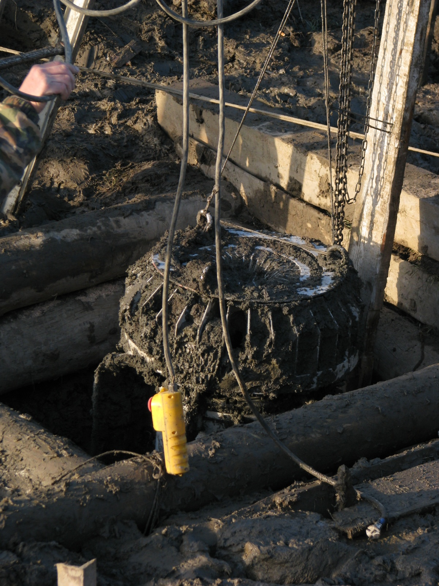
Figure 30. Removing RITEG from Thaw Sink
The RITEG was found upside down at a depth of 6-6.5 m from the bottom of the log frame on the right slope of the ravine. The capsular was shaped as an egg-like space with a diameter of 1.5 m and height of 1.9 m. Melt soil filled 90 percent of the space while 10 percent of the space was filled with water and gas. After the preliminary inspection, prevention and preparatory works, RITEG No.12 was lifted to the surface.
The second RITEG (No.13) was lifted from a depth of 8.5 m from the soil surface.
Both RITEGs were inspected, delivered to Tiksi Hydrographic Facilities (the owner) under the Delivery and Acceptance Certificate, prepared for transportation, moved to a horizontal area, and placed on wooden floor beams (No.12) and on a metal and plastic foam board (No.13). The area was surrounded with a wire fencing bearing radiation warning signs. Safety was mainly guaranteed by the absence of roads, remoteness of settlements (the nearest one is located at a distance of 200 km from the site), and lack of any economic or field activities near Kondratiev site in autumn and winter.
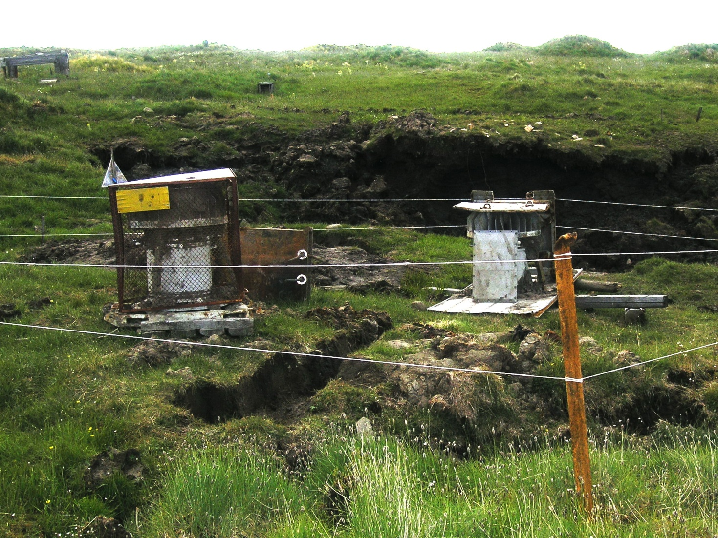
Figure 31. RITEGs Prepared for Transportation
RITEGs will be transferred to Tiksi in the spring of 2011.

The Project Outcomes

The RITEGs location, the depth of their permafrost submersion, the newly formed profile of the area makes it possible to analyze and describe their movement in permafrost. In 2002, employees of the Hydrographic Facilities, that provided for navigation support for the maritime traffic in the Laptev Sea, found that the Kondratiev navigation sign had been completely destroyed and two RITEGs had been lost in Ust’-Yansky Rayon, the Republic of Sakha (Yakutia). The RITEGs kept on sinking during the entire period starting from the collapse of the terrace cusp irrespective of the season of the year. RITEGs were estimated to have moved at a rate of 1.6 – 1.7 m/year having gone down to a depth of 15 and 18 meters. What prevented the RITEGs from sinking even deeper was that they were equipped with trays-runners that acted as parachute brakes (both RITEGs were found upside down). In 7 years, the terrace cusp moved towards the mainland at a distance of 120-130 m, and the distance from the assumed location of the RITEGs to the terrace cusp grew to 180-190 m. From the terrace surface, RITEGs went down to a depth of 9.5 and 11.5 m. Since the pit was excavated in one of the ravines formed on the terrace surface, the depth of excavation was only 3 m.
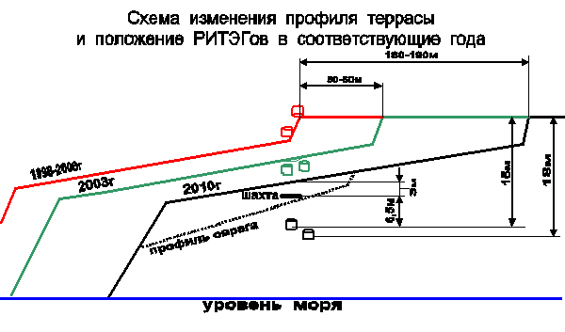
Figure 32. Diagram of Changed Terrace Profile and Location of RITEGs in the Corresponding Years

All the Project equipment items were used. Moreover, there were stand-by devices and equipment as the works were to be carried out in the permafrost conditions in a remote and hard-to-access location. The most needed piece of equipment turned out to be the self-made electric pile hoist that was used in removing foreign items, soil excavation, and lifting RETEGs from the pit.

To carry out works associated with the search for buried RITEGs, it is recommended to apply a set of geophysical methods (magnetic surveys, transient electromagnetic method surveys and radiation measurements). In the arctic regions, geophysical methods in the search for items such as RITEGs, buried in the permafrost soil, must be used in the absence of snow cover. Where the search site has a lot of metal items, such works should be carried out in summer with the maximum thawing of the soil. This will make it much easier to clean the search location from interfering items. This set of geophysical methods will also be good at searching metal items if they have been buried as a result of landslides or other processes.

It is recommended to drive the pit in the permafrost soil only at temperatures below zero. This will exclude cave-ins or water ingress into the pit and will make it possible to do directional or horizontal digging. Also, temperatures below zero allow the use of heavy track-type machinery or other machines for auxiliary and transportation purposes.

2.11. Pilot Project: Inventory of Pollution Sources at the Decommissioned Military Sites on the New Siberian Islands.

The Project goal was to assess the pollution levels within the decommissioned military bases on Kotelny and Bolshoy Lyakhovsky Islands of the New Siberian Islands and to prepare remediation proposals for these territories.

The Project was implemented by nonprofit organization “The Foundation for Polar Research “POLAR FOUNDATION”.

The Project Duration: 31 August to 30 November 2010

The Project Activities:
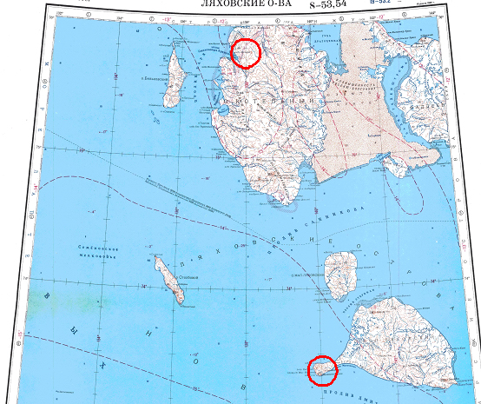
Figure 33. Location of Decommissioned Military Bases on Bolshoi Liakhovsky Island and Kotelny Island

Phase 1.

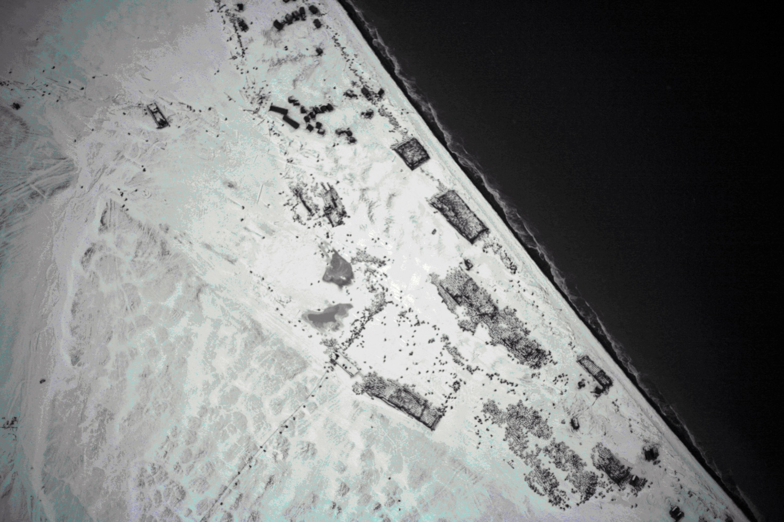Figure 34. Numerous Drums and Military Hardware on the Coast of Stakhanovtsy of Arctic Bay, Kotelny Island
1.1. Charting by means of aerial survey and terrestrial geodetic survey of the main pollution sources within the decommissioned facility of the Russian Ministry of Defense on Kotelny Island (65 ha) were carried out, namely:
- infrastructure facilities, abandoned machines and buildings;
- 200-l metal drums containing oil products, waste oils, oil products residues and other liquids;
- large capacity tanks for the storage of oil products;
- abandoned technological equipment, powerful transformers and condensers as part of the airport and radar equipment;
- domestic and construction waste dumps.

1.2. Charting by means of aerial survey and terrestrial geodetic survey of the main pollution sources within the decommissioned facility of the Russian Ministry of Defense on Bolshoy Lyakhovsky Island (25 ha) were carried out, namely:
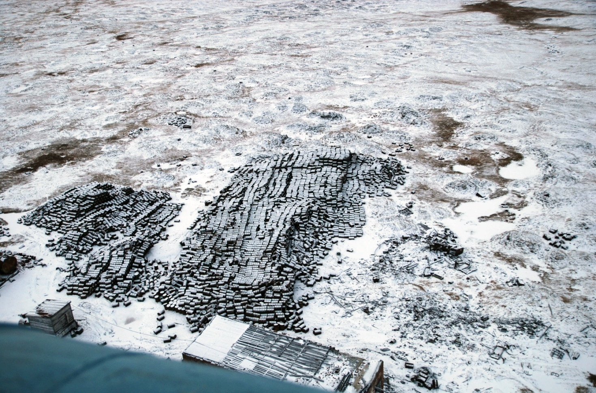
Figure 35. Aerial View of Empty Drums Storage South of Diesel Station on Bolshoi Liakhovsky Island
- infrastructure facilities, abandoned machines and buildings;
- numerous 200-l metal drums containing oil products, waste oils, oil products residues and other liquids;
- large capacity tanks for the storage of oil products;
- abandoned technological equipment;
- domestic and construction waste dumps;
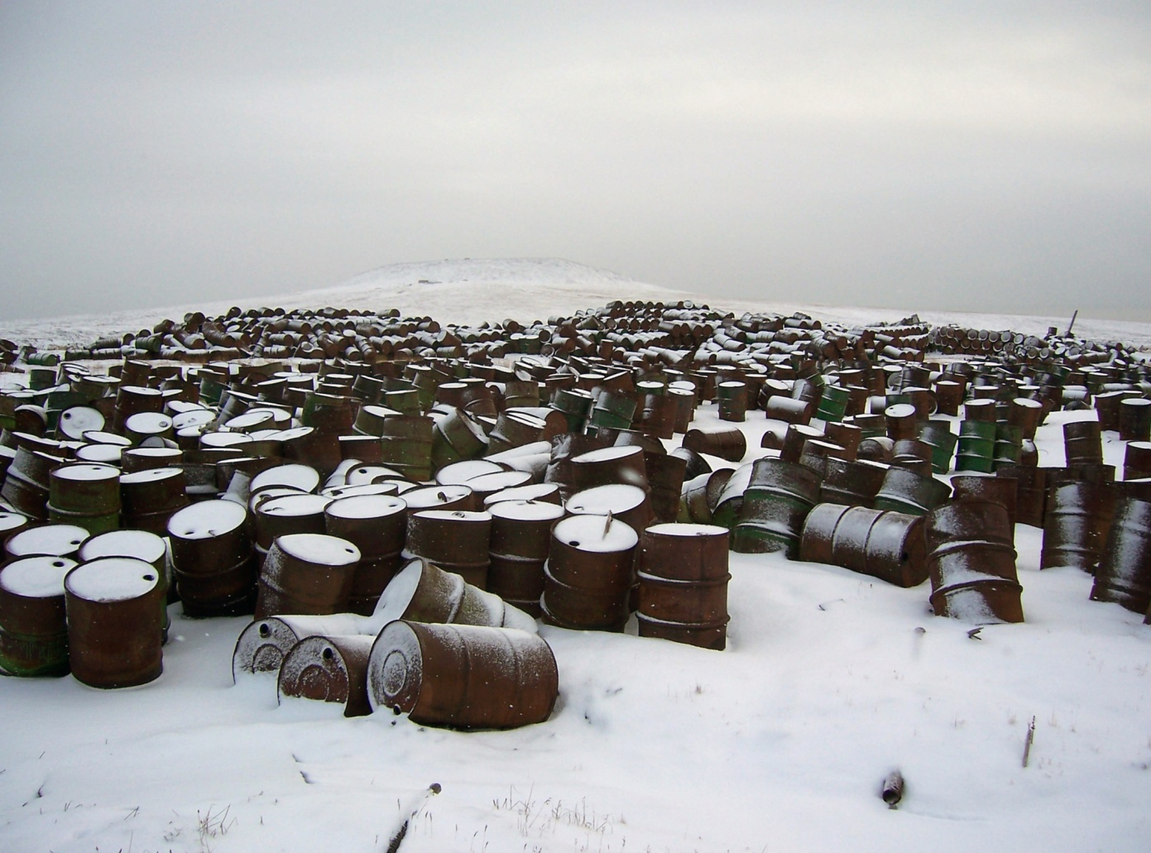
Figure 36. Dump of Steel Drums Filled with Fuel and Lubricants to Varying Capacity

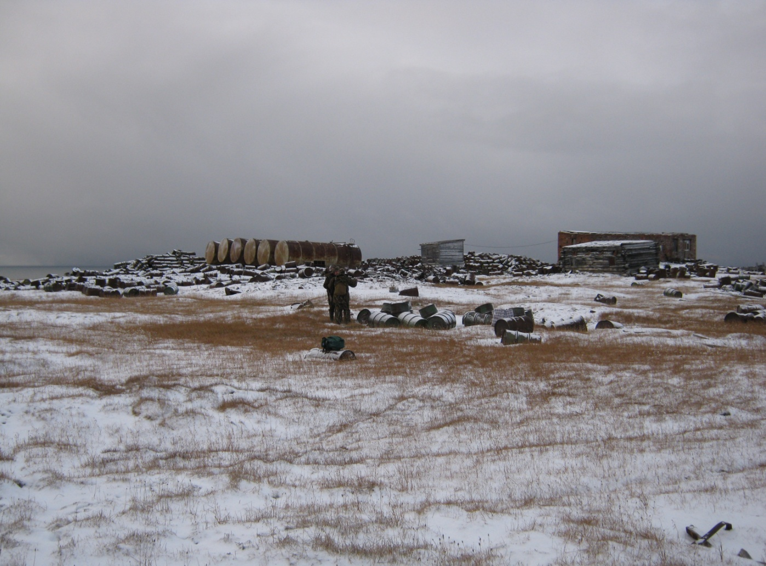
Figure 37. Tanks Near Diesel Station on Bolshoi Liakhovsky Island

1.3. Taking samples of (i) oil products, other technical liquids stored in containers to identify their contents and level of POP concentration; (ii) soils near the pollution sources and within the contaminated territories to identify pollution by oil products and PAH, PCB and heavy metals.
The Temp Civil Airport was also surveyed, with the survey coverage of 40 ha.

Phase 2.

2.1. Chemical analysis of samples
2.2. Processing the survey results in the office including:

- Establishing categories of the pollution sources;
- Establishing 1:1000 bitmaps of the surveyed territories;
- Preparing digital thematic maps of pollutions;
- Preparing and writing the status report;

The Project Outcomes

Leakages from the deteriorating tanks for the storage of diesel fuel, waste oils and other process fluids are the main source of pollution. In order to identify the fluids accumulated at the facilities, the Project took 19 samples, with 10 samples displaying the presence of heavy metals and PCB.

In order to characterize the surface flow migration patterns of pollutants, the Project took samples from the stream that drained Sites No.4 and No.6 of the Air Defense Station on Kotelny Island.

The orthophotomap and site investigation provided data to estimate the amount of tanks and drums stored on the above sites. In accordance with the overview photos, a similar estimation was made for the adjacent areas located beyond the survey sites.

Estimation of the Amount of Drums Stored within the Surveyed Sites
Site | Estimated Amount (drums)
Air Defense Station, Bolshoy Lyakhovsky Island | 30000
Bolshoy Lyakhovsky Island, the coastline of Malakatyn Bay and City of Malakatyn-Chokur | 5800
Total: | 35800
Air Defense Station, Kotelny Island | 51700
Kotelny Island, the coastline of Stakhanovtsy Arctic Bay | 20600
Kotelny Island, Temp Airport | 25600
Total: | 97900

The above estimation did not cover isolated drums dispersed across the entire territory, the share of which could reach more than one percent of the amount shown in the above Table.

High levels of hydrocarbon pollution were found on all the sites. This is a dispersed pollution.
Within the abandoned military facilities, 22.5% (Bolshoy Lyakhovsky Island) and 28.8% (Kotelny Island) of samples demonstrate the contamination levels above the intervention levels. Within the Temp Airport, intervention level was found to be higher in 5 samples out of 7 (70%).

Average and Maximum Concentration of Petroleum Hydrocarbons in Soils as a Share of the Intervention Level (5,000 mg/kg)
Exceeding | Bolshoy Lyakhovsky Island |  |  | Kotelny Island, Defense Station |  |  | Temp Airport
 | Site 1 | Site2 | Site3 | Site4 | Site5 | Site6
Average. | 2.7 | 12.6 | 2.7 | 3.4 | 0.6 | 3.1 | 18
Max. | 13.4 | 20.4 | 7.9 | 15.6 | 1.0 | 9.6 | 105

The acreage with the sol contamination levels above the intervention level is as follows:

- The Air Defense Station on Bolshoy Lyakhovsky Island: 4.6 ha;
- The Air Defense Station on Kotelny Island: 6.4 ha;
- Temp Airport: 3-5 ha;

Leakages of fuel and lubricants from the deteriorating and corrosive drums are the source of this contamination. In addition to full drums, empty drums also contribute to contamination. For instance, two samples taken from drums showed oil hydrocarbons polluted water that gets into drums with melt and storm water. Water would flush out oil hydrocarbons that are stuck to the bottom and walls of the drums contributing to corrosion process. As a result contaminated fluid also gets into soil.
The study results clearly indicate dispersed heavy metal contamination both within the abandoned military facilities and in the adjacent areas. The contamination levels are characterized as highly and extremely highly hazardous (the value of the total contamination of the Bolshoy Lyakhovsky Island facilities is between 149-193, while the Kotelny Island facilities contamination values range between 145 and 152. These anomalies were comprised of more than one element including cadmium, lead, copper, nickel, zinc, and tin. Some samples displayed extremely high levels of contamination with Hazard Class 1 elements. In particular, on Kotelny Island, the Site 6 sample exceeded the lead baseline contamination levels 700 times, while the Temp Airport sample exceeded the mercury baseline contamination levels 25 times.
Given the ways PCB gets into the environment, the samples showed local PCB contamination. But despite this fact, random sampling showed excessive PCB concentration in some cases as compared with the permitted levels (0.02 mg/kg) - 2.3 times on Bolshoy Lyakhovsky Island, and 1.2 and 4.2 times on Kotelny Island. For the islands, this appears to be sufficient justification for the inclusion of PCB on the list of pollutants that are viewed as priority pollutants. The contamination levels (from 2 to 5 MPC) fall into the category of hazardous contamination levels.
Burning of fuel is the main source of PAH emissions. The abandoned facilities of the Russian Ministry of Defense have been abandoned for about 20 years and though the arctic conditions slow down the destruction of organic pollutants, their concentrations in soils are now lower. On Bolshoy Lyakhovsky Island and Kotelny Island, only 10 percent of the samples showed benz(a)pyrene (other substances are not regulated) concentrations that are 2 times higher than MPC. All such samples are from concave landforms (catholes, small ravines) located off the main sites. In wet shadowy soils, the destruction of organic pollutants takes longer than in the rest of the territory. Some samples (3 out of 40) displayed a slightly higher concentration (1 mg/kg) of total PAH (1.12 – 1.46 times).
These findings show that this pollutant is common across the surveyed facilities and sites but the contamination levels are within the permissible limits (up to 2 MPC) and there might even be a reduction trend.
Transformers were found during the walkover survey of the Air Defense Station and Temp Airport on Kotelny Island. They are open, and the covers are not fixed, but by the look of it, the bodies are good. There is fluid inside. The fluid levels are sufficiently high. In accordance with safety rules, direct sampling of the PCB-containing equipment was not done. It may be assumed that the transformers contain sovtol with water that gets into the transformers as precipitation.
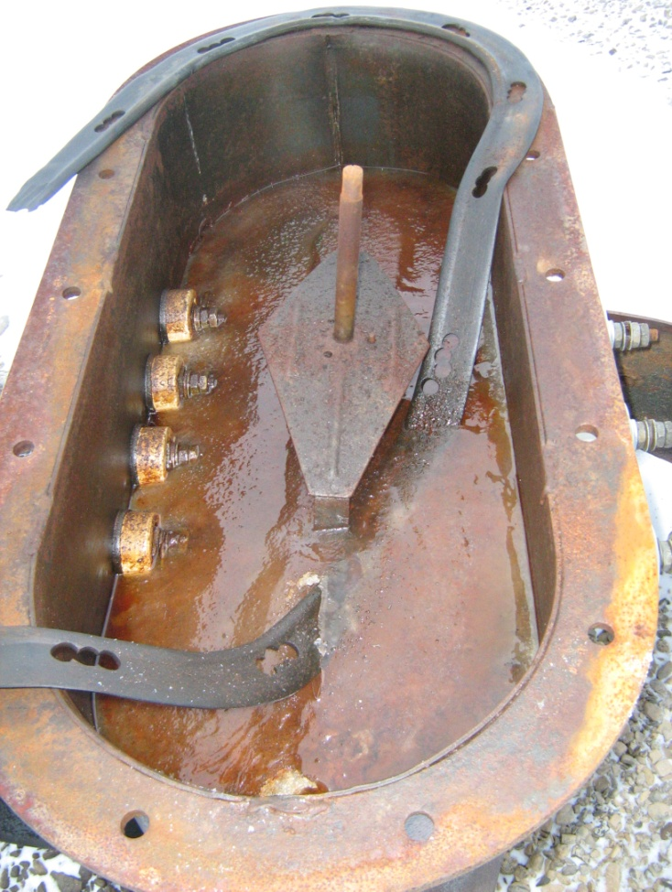
Figure 38. Abandoned Transformer as Potential Source of PCB

For the purpose of identification, 19 samples were taken from numerous drums and tanks that are accumulated on the sites and partially filled with process fluids. In most cases, winter diesel fuel was a prevailing fluid with depressor additives. There was also summer diesel fuel, motor oils, and waste oil mixes. On all the sites, the drums and tanks did not appear to be in a good state of repair. There were corrosion pits, and numerous leakages. Water was found in two samples. Water would flush out oil hydrocarbons that are stuck to the bottom and walls of the drums accelerating the corrosion process. As a result contaminated fluid also gets into soil causing contamination.
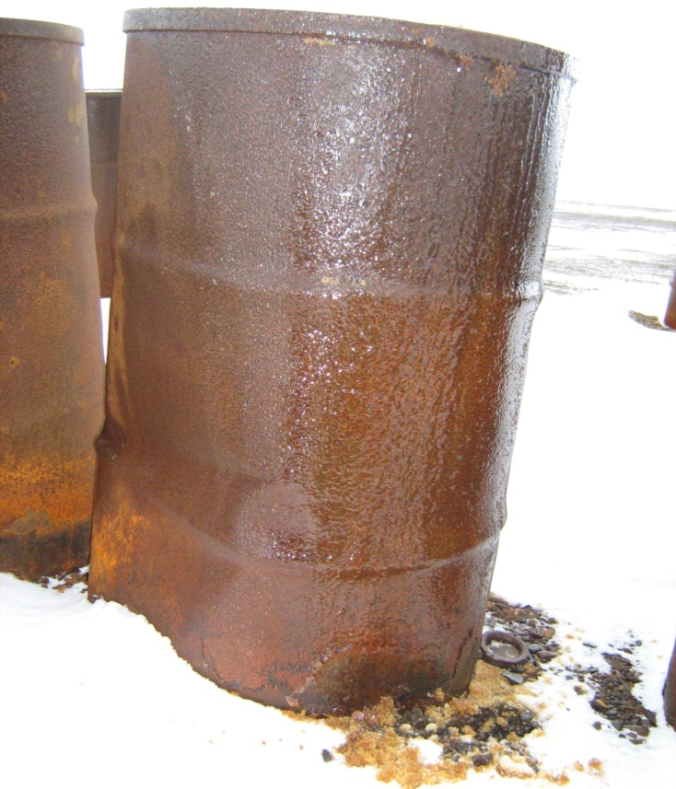
In order to assess the surface flow migration of pollutants, a water sample was taken at the congruence of the brooks draining from Sites No.4 and No.6 (the Air Defense Station on Kotelny Island). In accordance with the COD value (437 mg О2/dm3), the brook water falls into the category of wastewater. According to Annex “ZH” to SNiP 11-102-97, the COD >80 mg О2/dm3 characterizes the situation as an environmental disaster. Concentration of oil hydrocarbons in water is 1.82 mg/dm3 (36.5 MPC). Concentration of copper and lead could be as high as 14 MPC. The high contamination level of water is an integrated indicator of pollutants accumulation in the soil cover. This assessment is particularly informative in the context of local contamination.
The general approach to the development of measures aimed at eliminating pollution sources and the follow up remediation of lands in the high arctic was proposed under the demonstration project “Rehabilitation of the Environment near the Decommissioned Military Facility on the Franz-Josef Land Archipelago”, 2007.
Figure 39. Drum Leakages
The preliminary investigation of the current environmental status of the surveyed sites on Bolshoy Lyakhovsky Island and Kotelny Island indicated that the nature and extent of contamination within the decommissioned military facilities on the Franz-Josef Land Archipelago and New Siberian Islands are very much similar.
As is the case with the facilities on the Franz-Josef Land Archipelago, the technological disturbance of the territory comprises the following disturbances:

- Point (stored) and dispersed accumulations of drums and tanks (empty and with fuels and lubricants);
- Abandoned military, vehicles and other machines and equipment;
- Infrastructure facilities such as various pipelines, cables, transformers, diesel generating plants;
- Capital buildings with a different extent of destruction;
- Abandoned radio-electronic equipment, including radars, airport equipment, etc.

The survey results gave an opportunity to determine a preliminary list of the main activities for the cleanup of the sites. Priority No.1 is to carry out detailed pre-project site investigation works in order to better determine the cleanup scope including:

- Identifying sections with hazardous and highly hazardous levels of oil contamination detailing the areas of earthing, the amount of soil to be excavated and buried;
- Identifying the total area to be cleaned up;
- Specifying the parameters and structural elements of buildings and structures to be torn down;
- Specifying the full number of oil tanks and drums for the storage of oil products in warehouses, the amount and type of unrecorded balance of oil products and other process fluids to be shipped away or disposed of in-situ;
- Specifying the amount of industrial garbage, construction waste, domestic garbage, ferrous and non-ferrous scrap, waste drums accumulated on the sites and to be generated when tearing down technological and domestic facilities;
- Determining the types of works for the cleanup of the territories surveyed;
- Site investigations of the auxiliary facilities sites required for the total cleanup of the sites;

Based on the results of the site investigations and surveys, TOR for the development of the project design and cost estimates should be prepared. It will also be necessary to address the issues related to the property issue of the sites and facilities including succession issues after the completion of the site remediation project.

Developing and implementing a project for the cleanup and remediation of contaminated lands in the Russian Arctic is a rather expensive initiative, which must have the corresponding financing from the federal budget. A customer should also be identified. In this case, it could be the Ministry of Natural Resources and Ecology of the Russian Federation with the participation of the Government of the Republic of Sakha (Yakutia) and experts from the Russian Ministry of Defense.

The potential project is likely to be developed and implemented by organizations - winners of the corresponding competitive bidding within the government procurement system. It would be practical to propose to take into account the corresponding experience gained in the course of planning and implementation of demonstration and pilot projects, in particular those implemented under the UNEP/GEF Project “Russian Federation – Support to the National Action Plan for the Protection of Arctic Marine Environment”.

2.12. Pilot Project: Elaboration of the Process and Logistics Options for the Implementation of the System for Collection and Utilization of PCB Wastes and PCB-Containing Equipment in the Russian Arctic

The Project Goal was to develop a mechanism for the implementation of priority projects in the context of the soon to be completed preliminary works for the ratification of the Stockholm Convention by the Russian Federation, including:

- Estimating the amount of PCB wastes and PCB-containing equipment in the Russian Arctic;
- Preparing the Schematic Map indicating the main storage locations of PCB wastes and PCB-containing equipment in the Russian Arctic;
- Preparing an organizational and methodological framework for the establishment of a management system for the collection and utilization of the PCB wastes and PCB-containing equipment in the Russian Arctic including removal of PCB from the electric equipment and tanks, utilization of liquid PCB, utilization of capacitors, transformer and tank components, flushing of transformers;
- Evidence-based process and logistics proposals as the best application options for the Arctic with due regard for the earlier proposals for the collection and utilization of PCB wastes and PCB-containing equipment;

The project was implemented by OOO “Research and Production Facility “Centre for Landscaping and Waste Management”.

The Project Duration 07 July 2010 to 30 November 2010

The Project Activities

- A review of the Russian and international experiences in the collection and destruction (utilization) of PCB wastes and PCB-containing equipment in the Russian Arctic to identify best practices for use in the Russian Arctic.
- A review of the existing regulation framework for the collection and elimination (utilization) of PCB wastes and PCB-containing equipment in the Russian Federation and development of priority proposals for its improvement with due regard to the provisions of SAP-Arctic and international experience including the outcomes of the earlier projects.
- Inventory of PCB wastes and PCB-containing equipment in the Russian Arctic; preparation of the schematic map indicating the main storage locations of PCB wastes and PCB-containing equipment in the Russian Arctic;
- Review of the best available technologies for the utilization of PCB wastes and PCB-containing equipment.
- Assessing whether it would be more practical to refill transformers rather than to destroy them; providing for technical options of cleaning transformers and disposing of PCB extracted from the transformers, as well as of destroying capacitors;
- Preparing analytical materials and rationale for proposals to select the best available technologies and technical options, while estimating the required number of installations/plants, the number of stationary and/or mobile installations and their locations;
- Holding a meeting on the outcomes of the Pilot Project involving the relevant environmental authorities and stakeholders;
The Project Outcomes
In line with the objectives and Action Plan of the National Arctic Policy of the Russian Federation, it will be necessary to establish a comprehensive security system to protect the territory, population, and facilities in the Arctic from the risks of natural and man-made disasters. In the context of environmental safety, it is necessary, in particular, to provide for the disposal of toxic industrial waste and chemical safety in the residential areas.
An inventory of waste in the Russian Arctic must serve as the main database for tackling the problem. The Inventory will assess the quantity and composition of wastes, their location, identify the owners of wastes, and, most importantly, will legalize the presence of wastes. The Inventory will help regional administrations to make informed decisions concerning destruction or disposal of wastes.
Information obtained as a result of this work will be used in calculating the economic costs of environmental activities such as the procurement of equipment, collection and classification of waste, shipping them to the processing site, etc.
The assumed PCB wastes in the Russian Arctic are leftovers from human activity. These are likely to include the remains of buildings, electrical substations, boiler houses with heating systems, tanks, containers, drums with oil residues and Sovol, as well as oils containing polychlorinated biphenyls (PCB). PCB-containing Sovols were used in transformers and other equipment, electrical substations, and in heating systems, as good non-freezing coolant. They have not been manufactured in this country since 1993.
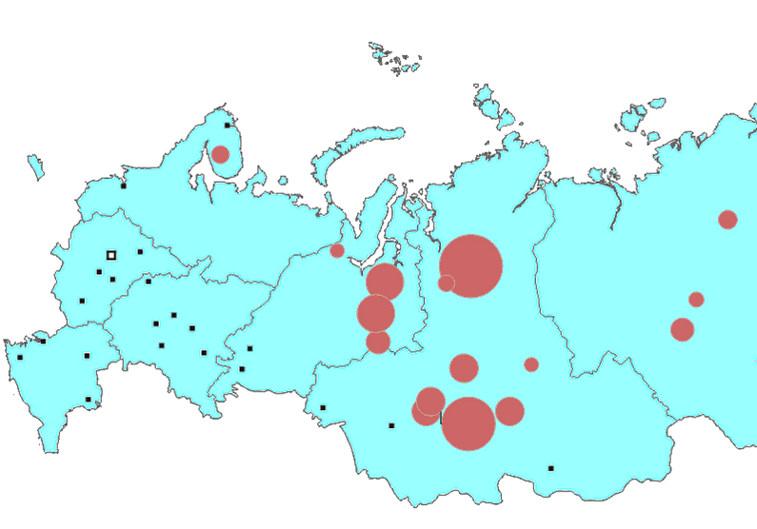
Figure 40. Schematic Map of PCB and PCB-Containing Electric Equipment in the Russian Federation
In three nearby Central, Northern, and North-Western Federal Okrugs, there is more than 4,000 ton of PCB in PCB-containing equipment used and stored in the chemical and petrochemical industries, ferrous and nonferrous metallurgy, machinery, forestry sector. The 2000 inventory of PCB and PCB-containing equipment established that there was PCB-containing equipment (transformers and capacitors) in Murmansk Oblast, Yamalo-Nenets Autonomous Okrug, Krasnoyarsk Krai and the Republic of Sakha (Yakutia). In the territories that are part of the Russian Arctic, there is about 1,269 ton of PCB. Almost the entire PCB stock was found in Krasnoyarsk Krai - 990 t (78% of the total) and in the Yamal-Nenets Autonomous Okrug - 235 t (18,5%). It may be assumed that these figures are not very precise, and most likely underreported. It will be necessary to make a comprehensive and detailed inventory and registration of PCB and PCB-containing equipment and their locations in the Russian Arctic. This inventory should serve as a basis for the development of a detailed PCB destruction action plan.
The pilot project also conducted an analytical review of the regulatory requirements to safe storage of stockpiles of PCB and PCB-containing wastes in the Russian Arctic, including requirements to a full range of necessary actions for the disposal of PCB-containing equipment: draining PCB, washing the equipment, neutralizing the equipment (including transformers, capacitors and empty PCB containers), and destruction of PCB and PCB-contaminated waste. A very important aspect of PCB waste disposal in the Russian Arctic is to develop special requirements to the system of collection, transportation, storage and destruction of PCB and PCB-containing equipment. There are currently no such requirements.
High-temperature processes are used to directly process such toxic chemicals as PCB. Self destruction of polychlorinated biphenyls will be at a temperature that is not less than 1100 ° C and PCB should be in the reaction zone for at least 1-2 seconds. In this way, there will be no secondary dioxins (PCB belongs to dioxins) generated.
In the international practice of thermal decontamination, the following process options are applied for such compounds: fired-heater reactors, fired-heater reactors with additional plasma afterburning of off-gases, fired-heater reactors with additional plasma heating of the reaction mixture, and plasma-arc reactors. All the PCB processing installations in the Russian Federation are experimental and none of them has currently a positive conclusion of the state environmental review.
The pilot project report discussed matters related to the organization of environmental monitoring at those locations in the Russian Arctic where PCB and PCB-containing equipment are operated, stored and disposed of. There is also a review of the regulatory requirements. It is noted that Russia operates only 4 specialized laboratories capable of environmental monitoring of PCBs and dioxins. To ensure the technical capacity of PCB monitoring at the facilities that operate PCB-containing equipment, as well as in the storage and disposal areas, it will be necessary to furnish the existing specialized laboratories with modern analytical instrumentation and to establish new laboratories staffed with skilled professionals.
The Report also describes the evidence-based process and logistics proposals as the best application options for the Arctic with due regard for the earlier proposals concerning the collection and utilization of PCB wastes and PCB-containing equipment. They include themes such as the selection of PCB destruction technologies, technologies for the treatment of transformers, treatment or destruction of capacitors, including matters related to the feasibility studies of such activities, performance of individual modules, number of individual installations and selection of sites for the disposal of PCB and PCB-containing wastes.
The proposed scheme of preparation for PCB waste thermal disposal of in the Russian Arctic includes:
- Selecting a thermal destruction installation;
- Establishing a thermal destruction station comprised of two 500 kg/h (at least) furnaces with (the capacity will be specified after the PCB waste to be destroyed has been identified); two furnaces are required because the furnace refractory life is usually not more than 6000 hours (one furnace is under repairs, the other is in operation). A thermal destruction station should be located in an industrial area of one of the nearby cities after having selected the best distance for waste transportation.
- Collecting PCB in special containers in places where it is kept and delivering PCB to the thermal destruction station;
Another important focus in waste collection is degassing empty PCB containers after PCB has been drained (drums, containers, tanks, etc.). This problem should be dealt with in parallel with the main objectives since the degassing solution must also be thermally destroyed.
In order to have a full environmental insight in the process of establishing the PCB inventory, it will be necessary to take soil samples for PCB to decide whether remediation of soil is required. If PCB is found near a water body, PCB water samples must also be taken.
The main difficulties in this work will be to obtain information about PCB-containing wastes and select a site for the construction a PCB thermal destruction station. Therefore, good motivation proposals will be needed to address these issues.

2.13. Pilot Project: Developing Healthcare Improvement Recommendations for Indigenous People Exposed to Intensive Adverse Impacts from Contaminated Environment in the Russian Arctic

The Project Goal was to (i) assess changes in the intensity adverse effects of POPs on people living in the Chukotka AO, and (ii) develop implementation recommendations on methods - adapted to the conditions of polluted arctic communities - of assessing and planning corrective and rehabilitation measures.

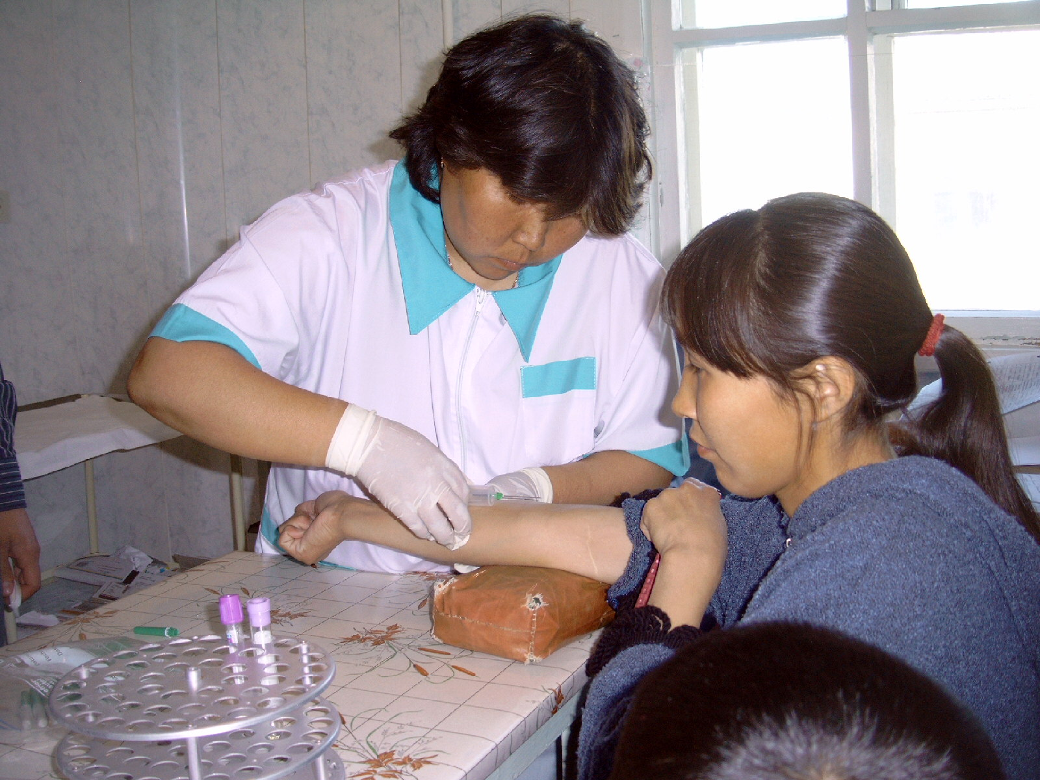Figure 41. Medical Screening Indigenous People from Communities of Chukotka Autonomous Okrug

The project was implemented by FGU Northwest Public Health Research Center of the Federal Service for Supervision in the Area of Consumer Rights Protection and Human Welfare.

The Project Duration 25 May – 30 November 2010

The Project Activities

To meet the Project goal, the Project:

- Conducted another health survey of a cohort of indigenous people including 30 women and 30 men living in indigenous communities of the Chukotka Autonomous Okrug (CHAO), participants of the 2001 survey;
- Described and carried out a comparative analysis of the temporal trends in the formation of human exposure to lead, mercury, cadmium compounds and other pollutants:
- In the settlements of CHAO, where land remediation activities were carried out in accordance with the internationally approved recommendations of the 2001 GEF/AMAP Project (the villages of Kanchalan, and Lorino);
- In the control villages of CHAO that did not participate in the implementation of the 2001 GEF/AMAP Project recommendations (the villages of Tavaivaam, and Ualen);
- Developed implementation recommendations for the improved methods of (i) assessing the socio-economic efficiency, and (ii) planning measures aimed at protecting the population the Russian Arctic from the adverse effects of pollutants.

The Project Outcomes
The pilot project generated new research data allowing for (i) the evaluation of changes that occurred since 2001 in the intensity of the adverse effects of persistent pollutants on people living in CHAO, and (ii) development of a set of additional recommendations on the application of corrective and rehabilitation measures adapted to the conditions of polluted Arctic communities.
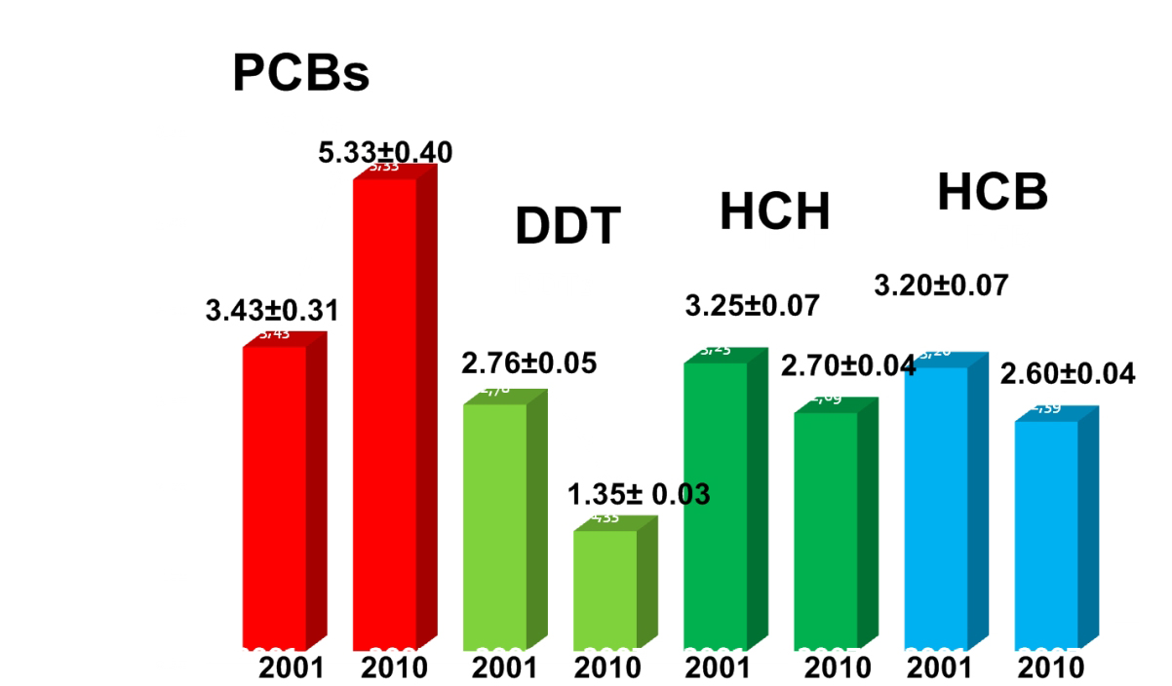
Figure 42. Changes in the Content of Main POPs in the Blood of Mails, Chukotka Autonomous Okrug Between 2001 and 2010
1. The health and ecological survey of 30 men and 30 women, which was carried out in accordance with the protocol similar to that applied in the survey of these persons in 2001, showed that in the subject cohort of the indigenous people of CHAO, the body levels of the vast majority of persistent toxic substances entering the Arctic through global transport of pollutants displayed a statistically significant downward trend.
2. However, over this period the blood levels of pollutants entering the environment from mostly local sources - primarily, PCBs and lead - showed a substantial increase among males, despite the implementation of recommendations on reducing the risk of adverse effects from persistent toxic substances (POP), as developed by an international panel of experts of AMAP.
3. The 2003-2006 special training workshops for indigenous people of CHAO failed to significantly raise their awareness with respect to the risks of adverse effects of POPs and measures for their prevention.
4. In CHAO, there was a substantial increase – especially over the last three years – in total mortality and, in particular, in the cumulative trend of frequency of diseases associated with adverse human impacts of PCBs. At the same time, there was little change with regard to the trends in the frequency of diseases that did not appear to be associated with adverse effects of the above group of POPs.
5. There appeared to be a weak positive correlation between the average performance of students in primary schools and PCB cord blood levels of at birth. This correlation was higher in the cohort of children living in those communities, which did not participate in the recommended program for the reduction of adverse effects of POP.
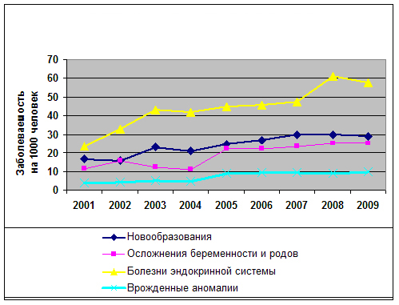
Figure 43. Diseases Potentially Linked to Persistent Toxic Substances
6. The pilot project was not tasked to determine the causes of observed changes in the intensity of the adverse effects of POP on the indigenous population. However, we can assume that the poor performance of the interventions for the remediation of POP- contaminated communities was caused by accelerated "opening up" of hazardous waste dumps due to the ever growing thawing of permafrost soils and increased ingress of such waste into the environment in connection with the observed climate changes. An indirect evidence of this might be the observed traces of the growing share of PCBs on the inner surface of housing constructions in indigenous communities.
7. The pilot project also identified the priority environmental risk of loss of health among the population of the Russian Arctic, assessed the contribution of specific diseases to poor demographic patterns and quality of life, discussed some questions related to possible causes of the poor performance recommendations on reducing the risk of adverse effects from persistent toxic substances (POP), as developed by an international panel of experts of AMAP and implemented in 2003 - 2009.
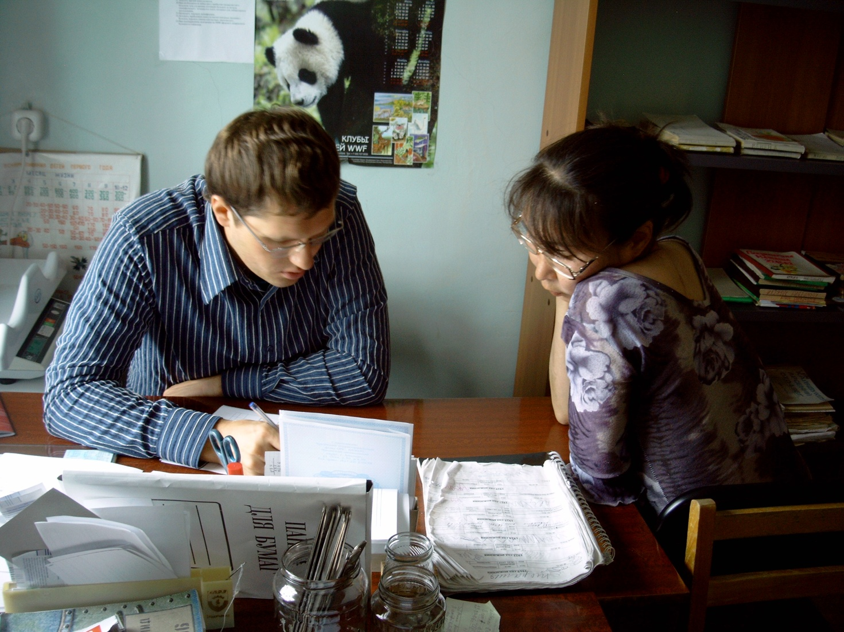
Figure 44. Discussing Indigenous People Screening Results with Local Healthcare Workers
8. The information on the poor performance of the programs served as a basis to develop additional recommendations on (i) the application of improved methods of assessing the socio-economic efficiency and planning measures aimed at protecting the population in the Russian Arctic from the adverse effects of pollutants; (ii) provision of the sanitary-epidemiological safety of population, including the improvement of measures to prevent health disorders associated with an exposure to POPs.
9. The fact that the community based training was given a poor rating indicates the need to radically change the training methods, which should be systematic (ongoing) and also cover children of school age (kindergartens, schools).

2.14. Pilot Project: Establishing the System of Obsolete and Banned Pesticides Destruction in the Russian Federation through Innovation Technologies

The Project Goal was to establish (i) the institutional capacity for the implementation of national plans and international projects related to the destruction of POPs in Russia, and (ii) a methodology for legalizing in a step-by-step way an innovative technology for POP destruction.

The Project was implemented by the noncommercial partnership “International Research Center for Environmental Impact Assessment (NP MNC OVOS).

The Project Duration 15 June – 31 December 2010.

The Project Activities

To attain its goals and objectives, the Project:

- Selected technologies and technical options suitable for pesticide destruction and compliant with the international requirements, and adapted to the Russian conditions;

- Developed technological procedures in accordance with the requirements of the best available technologies for pesticides destruction and Russian regulations; establishing the “technology – equipment” package of a specific structure to be submitted to the regulatory authorities of the Russian Federation;

- Carried out the environmental impact assessment (OVOS) of the “technology – equipment” package in accordance with the procedures as set forth by the legislation of the Russian Federation;

- Monitored, by way of chemical analysis, the operation of the hazardous waste destruction units and equipment at various regimes of the process cycle; submitted the results of field measurements to the designated body of the Russian Federation for approval;

- Conducted sanitary and epidemiological studies of the pesticides destruction technological process on the basis of the OVOS results and chemical analysis data;

- Informed the public in accordance with the requirements of the Russian legislation;

- Submitted the materials to the State Environmental Expert Review;

- Developed specifications of (TU/Standard GOST) for pesticides destruction technologies in accordance with the Federal Waste Classifier;

- Proved compliance of the technology and equipment with the applicable Russian regulations and requirements including TU or GOST to be developed;

- Established the full package of documents to allow importation, transportation and operation of the pesticides destruction technologies and equipment within the territory of the Russian Federation in accordance with its legislation

The Project Outcomes

According to the POP inventory, substantial amount of obsolete and banned pesticides in the Russian Federation are stored in dilapidated premises, which are not fit for storage purposes. In most cases, the packaging of these hazardous chemicals is disturbed and does not meet the requirements of the applicable legislation. All in all Russia accumulated not less than 40,000 ton of obsolete pesticides and pesticides that are banned for application in the Russian Federation. This poses a serious environmental risk for the Russian Arctic. In the Russian Federation and in the Russian Arctic it is impossible to tackle the problem of destructing the stockpiles of obsolete and banned pesticides without establishing the obsolete and banned pesticides management system. Such a system should include the institutional and legal framework, modern equipment for the destruction of various pesticides, and a wide regional network for the collection, transportation, safe storage and destruction of pesticides.

The project screened innovative technologies and technical options for the destruction of pesticides that meet international requirements and are adapted to the local conditions.

The use of fixed pesticides destruction installations in the Russian Federation is difficult because of the geography of locations where obsolete and banned pesticides are collected and stored, and because transporting hazardous waste across the country is a complex and costly affair. In this regard, the focus of screening was to search for and identify mobile modular units.

For Russia, such a solution is an innovative approach, unparalleled in the Russian practice, and requiring certain expenditures for its implementation in the Russian market.
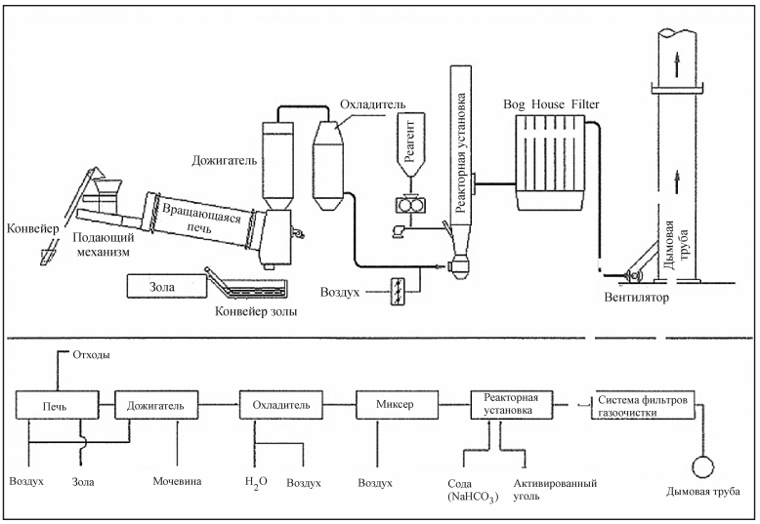
Figure 45. Diagram of Mobile Modular Unit for Incinerating Solid Obsolete and Banned Pesticides

As a result of this search and analysis, the Project selected a technology of an adiabatic high-temperature thermal treatment, based on a mobile installation unit, developed by the University of Florence, and marketed by FEROtech, an Italian company. The chosen technical option makes use of a base modular unit for the incineration of toxic waste, with an add-on module for the incineration of obsolete and banned solid pesticides (SCPWmk) and other halogen-containing toxic waste. Where destruction of liquid pesticides (LCPWmk) is required, the base unit can be supplemented with a specialized module.

The Project prepared a complete set of documents (process procedures, environmental impact assessment, technical specifications, resolutions on holding and approval of the public hearings results, field tests data, a letter of submission of documents to the state environmental expert review) enabling importation, transport and operation of a technology and equipment for the destruction of pesticides in accordance with the laws of the Russian Federation in its territory.
The result of the project is an institutional system of handling and disposal of pesticides, as a prerequisite for the transition to a phase associated with practical work for the destruction of obsolete and banned pesticides in the Russian Federation.

2.15. Pilot Project: “Improving the Oil Spill Response System in the Arctic Context for the Protection of Coastal Areas that are Specifically Responsive to Oil Products (as Demonstrated in the Context of the Barents and White Seas)”

The Project Goal was to develop proposals for improving the system of responding to oil spills in the Arctic context by the Russian emergency management services, port authorities and other specialized services and units for the protection of coastal areas that are specifically responsive to oil products.

The Project was implemented by OOO Rambol Barents.

The Project Duration 20 August – 30 November 2010

The Project Activities

To meet its goals and objectives, the Consultant:

- Analyzed Russian and foreign experience (including experience in the Nordic countries) of responding to oil and oil products spills in an environment similar to the Barents/Euro-Arctic region;
- Analyzed the current system for responding to oil and oil product spills in the Russian Arctic, and outlined the improvement priorities;
- Prepared maps of coastal areas that are specifically responsive to oil spills in the Barents and White Seas;
- Carried out computer modeling of the properties of the main oils and oil products transported through the Barents and White seas and studied their behavior on the water surface under different meteorological conditions;
- Analyzed cumulative environmental benefit from the application of various methods of (i) responding to an oil and oil products spill and (ii) protecting the coastal areas in the Barents and White Seas with specific response to such spills;
- Worked out a decision-making algorithm for the Russian emergency management services, port authorities and other specialized services and units concerning application of oil and oil spills response technologies;
- Prepared draft guidelines “Improving the Oil Spill Response System in the Arctic Context for the Protection of Coastal Areas that are Specifically Responsive to Oil Products (as Demonstrated in the Context of the Barents and White Seas)”
- Submitted proposals for an investment project concerning oil and oil product spill response in the Arctic context;
- Held the project completion meeting to provide for the dissemination of the project related experience among the stakeholders;

The Project Outcomes

The Project reviewed the Russian system of responding to oil spills at sea as an organizational structure based on three pillars, which were extensively studied and analyzed, namely:

- Legislative framework comprised of regulations governing the operation of the response system and interaction of its elements;
- Scientific and methodological documents including a set of sound methodologies and recommendations for the prediction and prevention of pollution, and the carrying out of oil spill response operations (OSR).
- Resource framework including a set of resources to tackle practical operational tasks with respect to the prevention of and response to oil spills (offshore and onshore infrastructure, specialized machinery and equipment, communications equipment, skilled staff, managers, equipment operators, manpower, financial provisions, insurance system, information resources, data collection and transmission system, etc.).
The analysis showed that after major oil spills with serious and, sometimes, catastrophic consequences, the world public and national governments understand the need in revisiting and improving the national oil spills response systems. Steps would be taken to strengthen international environmental standards and requirements. However, the existing environmental requirements and safety regulations at sea, both at global and national levels, can not to date guarantee that there will be no emergencies resulting in oil spills in the Arctic marine waters.
In the international and Russian practice, there are common approaches and methods for responding to oil spills in marine waters, but the choice of an OSR technology may depend on national rules and standards as adopted by a specific country. Nevertheless, all the Arctic countries find it too complicated or even impossible to use standard OSR technologies in the Arctic. It is necessary to find new response techniques that would be effective in the harsh natural conditions, particularly in the ice conditions.
For the Russian Federation, improving the regulatory and legal framework must be one of the top priorities in preventing and responding to oil spills. Regulation should focus on achieving long-term effects and synchronizing management decisions with other nations, first of all with all the Arctic countries.
In accordance with the national requirements of the Russian Federation, oil spill response operations should be planned and priority protection areas should be selected on the basis of risk assessments with due regard to local conditions, nature of the territory and water area, and its environmental characteristics. For background information in this case, one usually takes the data on the distribution of various species of animals and plants, presence of specially protected areas (PAs) and other valuable natural sites in the area to be affected by an oil spill. To this end, the Project prepared maps of "relative" and "absolute" vulnerability of the Barents and White seas from oil spills, taking into account seasonal differences. By using the "relative" vulnerability maps, one can compare individual sea areas during one season. However, where it is necessary to compare vulnerability between the seasons, one should use the "absolute" vulnerability maps.
The resulting maps show that coastal areas are the most vulnerable areas in the Barents Sea. This is primarily the Murman coast, and the coastal line along the west coast of Novaya Zemlya Archipelago. Highly vulnerable are also the eastern aeas of the Pechora Sea in winter and autumn. The entire water area of the Russian sector of the Barents Sea in summer and spring seasons is about 8 times more vulnerable than in winter, and 2.5 times more vulnerable than in autumn.
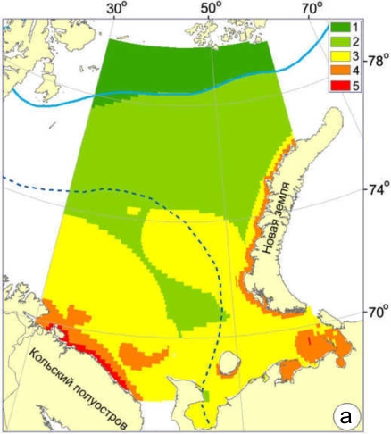
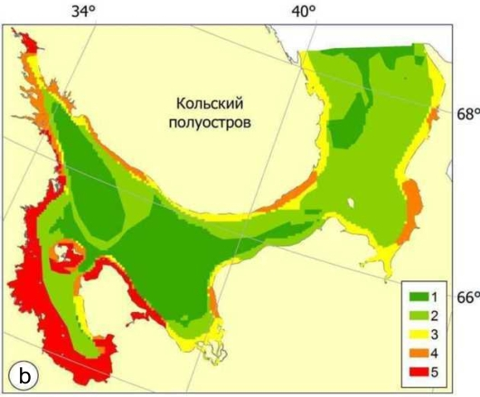
Figure 46. Examples of Maps of Integrated Vulnerability of the Barents (a) and White (b) Seas by Seasons
The White Sea maps of the integrated vulnerability show that in different seasons the coastal areas are the most vulnerable areas (as is the case with the Barents Sea). This is mainly the west coast of the White Sea from Kandalaksha to Onega Bay.
Based on the experience gained, the Project offered recommendations for mapping coastal areas with specific response to oil spills. The maps should provide clear and visual information to spill response teams. They should have an integrated characteristic of the coast structure and its morphological features expressed as an index of specific response to oil spills. They also should feature information concerning biological diversity, productivity and natural resources use sites in the coastal and marine areas. Different coast types must be indicated by symbols. Maps of coastal areas with specific response to oil spills should be prepared in three scales, with the corresponding information on them for each scale.
Small-scale maps should be a base map of the entire sea area including an outline of the shoreline, depth contours, contour line, the position of ice edge to reflect hydrological conditions and fishing areas, migration routes of marine biota. The charts of such a scale must show the main oil and oil products transportation routes, existing and planned terminals and pipelines.
Medium-and large-scale maps should show:
- Representative shores types with the environmental sensitivity index (ESI);
- The biological productivity of coastal waters and shoreline, as well as habitats and migration routes of birds and marine mammals, protected areas, important bird areas, and maritime marshes. The coast and shoreline should be ranked according to their vulnerability in terms of concentration of biota on the shore;
- Natural resources, recreational resources, sites of cultural, historic and scientific importance, access roads, coastal infrastructure, as well as the boundary of water protection zone for the Barents and White seas;
- The habitat beyond the tidal zone and coastal zone of fishing in shallow water, the areas for the collection of algae, shellfish banks in the intertidal zone or in shallow water near the coast, areas of fish and shellfish farming, rivers flowing into the sea, etc.
- Areas where dispersing agents can be used, and where they should not be used, where possible to deploy booms and their places of permanent mooring booms. It should show a "sacrificial zone", characterized by low vulnerability, which could if necessary, to send an oil slick for the salvation of areas of high ecological sensitivity (vulnerability), and places with paragraphs entrance.
In spills on water, oil behavior depends on oil properties. There are two distinct groups of most probable oil behaviors after a spill reaches the shore:
- Oil that is largely subject to the weathering process (e.g., evaporation and dispersion) and rapid natural decomposition of oil is expected. This group includes naphtha and gas condensate stable (CSC).
- Oil that is little subject to weathering process reaching the coastal zone virtually unchanged after the spill. This group includes crude oil and M-100 fuel oil.
The current practice in Murmansk Oblast demonstrated that the main objective of oil spill response activities should be to prevent oil from getting onto the coast, particularly into the areas of high environmental sensitivity. In this regard, the most relevant approach is to study whether it would be possible to use modern dispersing agents in the Barents and White seas, including in the coastal areas.
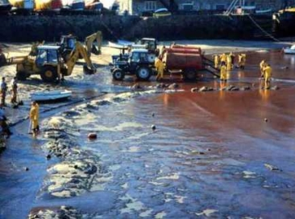
Figure 47. Cleanup of Oily Beach
The procedure for analyzing and selecting the most effective oil spill response approaches, whose application will minimize the negative impact on the environment, is called the Net Environmental Benefit Analysis (NEBA). The purpose of NEBA is to determine a response methodology to either reduce the time required for natural recovery, or to restore natural environment in the oil affected area to the levels that are as close to the natural levels as possible. NEBA involves an informed decision making process as to whether an oil spill response is really needed, given potential environmental consequences. The starting point is the reference conditions to be compared with the likely outcome of intervention. It is also necessary to analyze a) the need in the clean-up, and b) the choice of the technology to be applied. The level of damage should be analyzed as compared to the possibility of remediating the affected area. In some cases it is measured as a time period. Moreover, some intervention may cause additional damage, but overall, such intervention should minimizing damage.
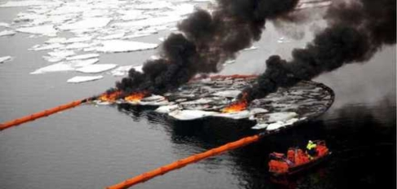
Figure 48. Testing Incineration Technology
Despite the fact that this is a rather obvious approach, there are many examples where the clean-up activities, undertaken with the intention of reducing the environmental damage, inflicted more damage than oil itself. In the Barents and White seas it is extremely difficult to combat large oil spills at sea. Although containment and mechanical recovery of oil is the preferred option of oil spill response at sea, there are many reasons why this may be an ineffective approach. In case of light oil spills the best response option will be to monitor oil spills until they decompose in an natural way, especially if the oil is far from the coast and rapidly decomposes.
This analysis served as a basis for developing a decision-making algorithm for OSR technique application. Mechanical techniques of OSR are the preferred approach to respond to an oil spill in the Arctic waters in terms of minimizing the impact on sensitive areas. The algorithm also includes alternative response techniques such as incineration and the use of dispersing agents. Taking into account the specific nature of oil spill responses in the Barents and White seas and the fact that particularly sensitive areas are located very close to the main waterways, this algorithm could undergo substantial optimization. Understanding that major oil spills in the Barents Sea could be of transboundary nature, it might be practical to develop common international guidelines and criteria for selecting OSR technologies for the Barents/Euro-Arctic Region.
The findings of the Pilot Project and stakeholder comments helped formulate proposals and recommendations that may be useful in developing measures to improve Russia's national OSR system and ensure the necessary level of preparedness to respond to potential oil spills in the Arctic. Suggestions and recommendations are divided into blocks according to the organizational structure of the oil spill response system, as adopted in the pilot project:
- Proposals and recommendations to improve the regulatory framework for the Arctic oil spill response system;
- Proposals and recommendations to improve the scientific and methodological framework for the Arctic oil spill response system;
- Proposals and recommendations to improve the resource framework for the Arctic oil spill response system;
The Project proposed the investment project "A Feasibility Study for the Establishment of an Intermediate Base Station for OSR Facilities on the Kola Peninsula Coast in Order to Ensure Timely Response to Potential Oil Spills". It includes a number of interrelated activities aimed at conducting a comprehensive study concerning the establishment of high-performance unit titled FGUP “Murmansk Basin Emergency and Rescue Management Administration" on a remote stretch of the Kola Peninsula coast. The goal of the project is to carry out a set of in-depth studies to fully and objectively evaluate the need in and feasibility of creating intermediate OSR base stations on remote stretches of the coast. For greater objectivity of the studies, they will be implemented as a demonstration project in a specific land area on the Kola Peninsula coast.
Experience gained under this pilot project, and draft recommendations were circulated among the organizations concerned. Additional recommendations received as comments and suggestions from OSR experts were reviewed and incorporated in the final draft Guidelines.
Details of the recommendations and the proposed investment project are in the report which is posted on the NPA-Arctic project site http://www.npa-arctic.ru.

